ONLINE EVALUATION SYSTEM FOR NON-ACADEMIC SCHOLARS OF ASIAN COLLEGE OF TECHNOLOGY

A System Study Presented to the

Faculty of the College of Computer Studies

Asian College of Technology International Educational Foundation

Cebu, Philippines

In Partial Fulfillment

of the Requirement for the Degree

BACHELOR OF SCIENCE IN INFORMATION TECHNOLOGY

by

RAYMUNDO R. ALFECHE JR.

OCTOBER 2018

LIST OF FIGURES AND TABLES

Figure Title Page

1. Outside of Asian College of Technology 16
2. Asian College of Technology Location Map 17
3. Business Use Case Model of OESNAS 28
4. System User Case Of Maintain User Account in Admin 11
5. System Use Case of Maintain User Account in Admin 29
6. System Use Case of Maintain User Account in Admin 20
7. System User Case of User Authentication 32
8. System User Case of Maintain NAS of Admin 34
9. System Use Case of Maintain Department 44
10. System Use Case of Maintain Evaluation 48
11. System Use Case of Maintain Attendance 56
12. Use Case of Process Evaluation 59
13. System Use Case of Generate Monthly Allowance 61
14. System Use Case of Generate Evaluation Results 62
15. System Use Case of Generate Renewal Remarks 64
16. Class Model of the System 66
17. The Component Model of Online Evaluation System   
    for Non-Academic Scholars of Asian College of Technology 67
18. The Deployment Diagram of Online Evaluation System for  
     Non-Academic Scholars of Asian College of Technology 68
19. Login Page 70
20. Admin Start Page 71
21. Adding of User page 71
22. Importing of user page 72
23. Viewing of user page 72
24. Viewing of user's information dialog 73
25. Adding of nas page 73
26. Importing of NAS page 74
27. Viewing all NAS page. 74
28. NAS profile page. 75
29. NAS Schedule page 75
30. NAS Attendance page 76
31. NAS Grade page 76
32. Schedule page. 77
33. Manage schedule info page 77
34. Daily Schedule Page 78
35. Question Category page. 78
36. Adding of question category dialog 79
37. Edit category dialog 79
38. Confirm Category Deletion Dialog 80
39. Evaluation Question Page 80
40. Add Question Dialog 81
41. Importing Evaluation Question 81
42. Working Dates Page 82
43. Daily Time Record Page 82
44. Import DTR Dialog 83
45. Department Page 83
46. Adding New Department Dialog 84
47. Edit Department Page 84
48. Figure 48: Edit Department Dialog 85
49. Monthly Allowance Report Page 85
50. Figure 50: Choosing of Evaluation Results Page 86
51. NAS Evaluation Results Page 86
52. NAS Evaluation Report 87
53. Renewal Remarks Report Page 87
54. Monthly Allowance Report Print Dialog 88
55. NAS Evaluation Results Print Dialog 88
56. Renewal Remarks Report Print Dialog 89
57. Evaluator Home Page 89
58. NAS Evaluation Page 90
59. NAS Evaluation Submission Confirmation 90
60. Evaluation Form Sample 102
61. Transmittal Letter 103
62. Current system flow on Evaluation of NAS in ACT 104
63. Proposed system flow on evaluation of NAS in ACT 105
64. Figure 63: Data Model of Online Evaluation System for  
     Non-Academic Scholars of Asian College of Technology 109

Table of Contents

[ACKNOWLEDGEMENT 7](#_Toc526420712)

[ABSTRACT OF THE STUDY 8](#_Toc526420713)

[Chapter 1 9](#_Toc526420714)

[RESEARCH DESIGN 9](#_Toc526420715)

[Rationale of the Study 9](#_Toc526420716)

[Related Literature 11](#_Toc526420717)

[Chapter 2 15](#_Toc526420718)

[THE PROBLEM 15](#_Toc526420719)

[Statement of the Problem 15](#_Toc526420720)

[Objective of the system 15](#_Toc526420721)

[Scope and Limitation of the System 16](#_Toc526420722)

[Significance of the study 18](#_Toc526420723)

[RESEARCH METHODOLOGY 19](#_Toc526420724)

[Research Environment 19](#_Toc526420725)

[Research Map 20](#_Toc526420726)

[Sources of Data 21](#_Toc526420727)

[Methods and Techniques 21](#_Toc526420728)

[Models 22](#_Toc526420729)

[Tools 24](#_Toc526420730)

[Development Process 25](#_Toc526420731)

[DEFINITION OF TERMS 27](#_Toc526420732)

[Chapter 3 28](#_Toc526420733)

[REQUIREMENTS ANALYSIS 28](#_Toc526420734)

[Functional requirements 28](#_Toc526420735)

[Non-Functional requirements 29](#_Toc526420736)

[Usability requirements: 30](#_Toc526420737)

[Use Case Model 31](#_Toc526420738)

[The Class Model 74](#_Toc526420739)

[Component Model 75](#_Toc526420740)

[Deployment Model 76](#_Toc526420741)

[Implementation Strategies 77](#_Toc526420742)

[Chapter 4 78](#_Toc526420743)

[DESIGN OF THE PROTOTYPE 78](#_Toc526420744)

[The User Interface 78](#_Toc526420745)

[Chapter 5 99](#_Toc526420746)

[COST AND BENEFITS ANALYSIS 99](#_Toc526420747)

[Benefits 100](#_Toc526420748)

[Chapter 6 102](#_Toc526420749)

[CONCLUSION AND RECOMMENDATION 102](#_Toc526420750)

[Conclusion 102](#_Toc526420751)

[Recommendation 102](#_Toc526420752)

[REFERENCES 103](#_Toc526420753)

[Appendix A 105](#_Toc526420754)

[GLOSSARY OF TERMS 105](#_Toc526420755)

[Appendix B 107](#_Toc526420756)

[MODELLING TOOLS 107](#_Toc526420757)

[Appendix D 113](#_Toc526420758)

[TRANSMITTAL LETTER 113](#_Toc526420759)

[Appendix D 114](#_Toc526420760)

[FLOW OF THE SYSTEM 114](#_Toc526420761)

[Flow of the System 114](#_Toc526420762)

[Proposed System Flow 116](#_Toc526420763)

[Appendix F 118](#_Toc526420764)

[PARTICULARS OF THE OPERATING COST OF THE SYSTEM 118](#_Toc526420765)

[Appendix G DATA MODEL OF THE SYSTEM 119](#_Toc526420766)

[Appendix H 120](#_Toc526420767)

[SAMPLE PROGRAM CODE 120](#_Toc526420768)

[CURRICULUM VITAE 274](#_Toc526420769)

# ACKNOWLEDGEMENT

The researchers would like to express their sincerest and deepest gratitude to the following for the unyielding help and support they have received all throughout the research period:

To Almighty God, for giving them the wisdom, strength, patience and

determination as they faced all problems that challenged them to complete this study.

To Mr. Artemio Cabrillos Jr., their thesis adviser, for guiding and giving his informative advises as they make the study.

To Mr. Angelbert Maghanoy, their subject instructor for supervising the deliverables needed in the documentation and brilliant insights.

To Asian College of Techonology administration, for giving the researchers a chance to conduct a study and for supplying the things that the researchers need to know with the regards to the current system of the restaurant.

Lastly, to their compassionate families, for both financial and moral support, love, motivation and guidance they have given to them.

THE RESEARCHERS

# ABSTRACT OF THE STUDY

Title of the Study: ONLINE EVALUATION SYSTEM FOR NON-ACADEMIC SCHOLARS OF ASIAN COLLEGE OF TECHNOLOGY

Synopsis of the Study: The Online Evaluation System for Non-Academic Scholars of Asian College of Technology aims to design and implement online evaluation. Which Department heads can evaluate their scholar on-line. The administrator can also manage evaluation and the scholar’s information, DTR, working dates and grade. This system intends to increase the speed of evaluation scholars and generating reports needed. Implementing this system gives a time-efficient opportunity to give the department head (evaluator) to evaluate their scholars without waiting for the evaluation form to be handed over as well as calculating allowance based on the daily time record from the biometric will more time-efficient. We have chosen to target the Web platform, because it is widely used and most accessible online. We developed this system using the Metro UI Framework for front end, Code Igniter for Server-side scripting and MySQL for the database.

Authors: Degree Conferred:

Raymundo R. Alfeche Jr. BSIT

School : ASIAN COLLEGE OF TECHNOLOGY

Address : Corner Leon Kilat and P. del Rosario St., Cebu City

Date Completed : October 2018

# Chapter 1

## RESEARCH DESIGN

## Rationale of the Study

The advancement of technology today has immersed itself towards education. The presence of technology has reached its maximum of providing sustainable technology towards quality education through delivery and effective learning. Asian College of Technology International Education Foundation is one of the highly growing private schools that embrace information and communication technology now. As they immersed themselves with technology through their institution and other forms brought about by information technology.

The staff and management of Asian College of Technology have problems in releasing scholar’s monthly allowance on-time due to the difficulty in calculating based in DTR generated from the biometric machine. NAS are always late on enrolment because of waiting the results of the evaluation from different departments. Calculating the evaluation results seemed to be a lot of work since there are almost a lot of NAS in the institution. Lastly, renewal remarks are always delayed resulting to late enrollment of scholars.

The researcher have proposed a system that will solve these problems; the researcher build an online evaluation system that will allow the evaluator evaluate their scholars online without waiting for an evaluation form and automate the calculation of evaluation results. Since automation and mobility are high on demand, the system built is a web application. With this system, the administrator and the evaluator will not have any issues in the inaccuracy of evaluation results, monthly allowance, and renewal remarks. Next, the system is also equipped in updating the information of scholars and in an organized manner. Finally, the researcher built a simple UI for easy navigation to lessen the odds and difficulty of the users.

## Related Literature

According to Ylanan et al (2004) inraising teaching performance is perhaps the policy directionmost likely to lead the substantial gains in student learning. In turn, the effective monitoring and evaluation of teaching is central to the continuous improvement of the effectiveness of teaching in a school. It is essential to know the strength of teachers and those aspects of their practice which could be further developed. From this perspective, the institution of teacher evaluation is a vital step in the drive to improve the effectiveness of teaching and learning and raise educational standards.

Andales, Bacarisas, Coronel and Gonzaga (2010) state that Teacher’s Evaluation System is a software which aims to evaluate the teacher’s performance based on the different categories that is being provided. This can greatly affect how the teacher’s performance is to be improve and appreciated. Specifically, this study lets the students and the school heads to evaluate the teachers’ skills, behavior, and their school year’s objectives which is based on the RPMS (Result-Based Performance Management System).

Lim et al., (2014) concluded that it is necessary to automate manual evaluation system to improve the way of processing evaluation and retrieving the data among the users and administrators. The purpose of the study is to speed up the pace of their system so that both the users and administrators can conserve time. The main concern of this study is the security system. For the safety of the information and data if the system, it should be insured that there are no third party programs such as malware; even hackers are prevented.

Institutions structure and locate their evaluation systems differently on their campuses. In general, institutions either organize evaluations through a central office on campus or within individual departments. With regard to the formative purposes of evaluation, the organizational location of evaluation systems can potentially influence the effectiveness of those systems. In particular, certain researchers advocate a departmental approach to evaluation. Advantages with this approach are: instruction and its improvement are often discipline specific and faculty most closely identify with their department and are more likely to seek guidance and information within their department. (Hativa, 1995).

Research on the validity and reliability of these different forms of evaluation is scarce and especially in comparison to the amount of research available on the usefulness of student rating forms. However, studies do recognize that these other forms of evaluation can provide more qualitative and comprehensive information but may nonetheless be biased. In addition, these approaches require significant amounts of time and commitment on the part of the institution and faculty members. Institutions are continuing to incorporate more of these methods, and research has begun examining the effectiveness and utility of these approaches as well. (Johnson & Ryan, 2000; Hoyt & Pallett, 1999; Hativa, 1995).

Stufflebeam et al... (1971) provided a new definition of evaluation which states that "evaluation is the process of delineating, gathering and providing useful information for decision making alternatives" (p. 40). This definition, which has already been cited, holds a lot of features. The Context, Input, Process and Product (CIPP) model, one of the widely known evaluation models developed by Stufflebeam is based on this definition. The most common among these definitions centers on the concept of gathering information for decision-making. In this regard, therefore it is appropriate to conclude that the evaluation is an instrument which brings about change through decision making thereby leading to change (improvement) in the educational program and/or process. To do this, only positive change is useful or desirable. Improvement indicates alterations and comes only as a result of actions or methods different from those currently in use. Therefore, to improve the activity program, a decision maker must know the various alternatives available to him/her and choose the ones which make positive impacts on his/her activity program. To make this choice implies an element of understanding the various alternatives in making decisions.

Evaluation-based decisions off student rating systems, which critics claim are too subjective. Some of the subjectivity in the evaluation process results from students rating areas of effectiveness that they are unable to access, which they identify as, 1) the goals, content, and organization of questions; 2) methods and materials used in delivery; and 3) evaluation of student work, including grading practices (Cohen, 1980; Cashin, 1989; McKeachie, 1997; 2006; Bain, 2004).

Manual system is retrieving, maintaining, security and filling of records consume lot of time and effort. There are some cases wherein misplaced of records are taking place because of the years gone by. Furthermore, these files were only kept in envelope, folder or wooden racks. There are also instances when the right information is given to the wrong person, which may affect quality of service. (M. Cantonas, 2008).

According to Aquino (2011), Importance of computer application is increasing day by day. In the latest decades of the millennium winning organization are those which are willing to integrate business strategy and computer information technology in plying their respective trades. The use of computer information technology results for them to be able to develop products fast and make decisions fast, ability to have fluid organization structures, able to cope with the demanding work force and external environment by the rapid development of innovative approaches and lastly using information system confirms the company’s mission vision.

# Chapter 2

## THE PROBLEM

### Statement of the Problem

This research aims to develop an Online Activities Evaluation System using a Web-based technology in Asian College of Technology (ACT).

Specifically, it answers the following problems:

1. Takes a lot of time to complete the evaluation.
2. It requires a hard copy of every questionnaire.
3. Hassle in computing the results of the evaluation.

### Objective of the system

This research aims to develop an Online Activities Evaluation System using a Web-based technology in Asian College of Technology (ACT).

Specifically, it aims to:

1. Time efficient in evaluating NAS.
2. Much easier, faster and accurate computing of results based on the Criteria.
3. Evaluation will be more accessible and paperless.

### Scope and Limitation of the System

The researchers aim to develop a system that focuses on Online Evaluation System for Non-Academic Scholars of Asian College of Technology, which is capable of:

1. Maintaining the following
   1. User accounts
   2. NAS
   3. Evaluation Question
   4. Attendance
   5. Grade
2. Process the following
   1. User authentication
   2. Registration of user accounts
   3. Importing of the following
      1. NAS
      2. Attendance
      3. Grade
      4. Evaluation Question
   4. Evaluation
   5. Compute the following
      1. Attendance
         1. Total number of Lates
         2. Total number of Absences
      2. Grades
         1. Total Average
      3. Evaluation
         1. Total Mean
         2. Mean Interpretation
3. Monitors the following
   1. Attendance
   2. Evaluation
4. Generates the following
   1. Evaluation results
      1. Total Mean
      2. Mean Interpretation
   2. Reports
      1. List of NAS with renewal remarks
      2. List of NAS with number of units to be taken

However, the following limitations are;

1. The system is not accessible offline.
2. The system can’t process DTR for attendance.
3. The system can’t process accomplishment reports.

### Significance of the study

The findings of this study will redound to the benefit of the school and to the in-charge person. The project’s goal is designed to help the in-charge person for the evaluation of the institution, as well as to improve the efficiency, effectiveness, time and data gathering of the required output. The study will be valuable to the following

Administrator. With the help of the online evaluation system, the administrator will now have lesser time in having results for the evaluation.

Evaluator. With the help of the online evaluation system, the evaluator will now have ease of evaluating their scholar on-line.

NAS. Late enrolment will be lessen because generating the evaluation results is generated automatically and the monthly allowance delay will be lessen because of the automation of the calculation based on the DTR.

School. Evaluation of the Non-academic scholars is part of gathering the information needed for the school to improve their future Non-Academic Scholars, in which is the main purpose of this evaluation system.

Future researchers. This study serves as the future basis in creating and, or enhancing the future system related to this study.

## RESEARCH METHODOLOGY

### Research Environment

The study was conducted at Asian College of Technology in College of Computer Studies located in Corner Leon Kilat Street and P. Del Rosario Street, Cebu City. The researchers conducted an interview to Director of Student Welfare and Services Dr. Andres S. Gotera. The school was established in the year of 1988.Mr. Rodrigo Bebot Abellanosa, the school founder, and Mrs. Viannie C. Loquero, as her co-founder. The school has three sessions morning, afternoon and evening session. It has four departments namely; College of Computer Studies, College of Business and Management, College of Arts and Sciences Pedagogy and Senior High School Department.



Figure Outside of Asian College of Technology

### C:\Users\Krischan\Desktop\act map.JPGResearch Map

Figure : Asian College of Technology Location Map

### Sources of Data

A system could not be possible without any data that can be used in creating it and it is one of the most important aspects that will give knowledge to the researchers on how to solve the problems they are working in conducting the study

Research. To gains more data the researchers gather the information in the unpublished thesis from the library of Asian College of Technology, document review and electronic sources.

### Methods and Techniques

The following methods and techniques were used in the development of the proposed system:

Structured Analysis and Design Technique. The researchers used this technique to describe systems as a hierarchy of functions, a structured analysis modeling language, which uses two types of diagrams: activity models and data models.

Project Management Technique. The researchers used this technique to monitor the progress of the capstone project by using Gantt chart.

User-Interviewing Technique.The researchers used this technique to create a valuable method for exploratory user research.

Relational Database Technique. The researchers used this technique to maintain relational databases and also to be relatively easy to create and access.

### Models

The following models were used by the researchers that serve as the graphical representation to analyze the different aspects and the flow of the proposed system:

Use Case Diagram. This model was used by the researchers to show the interaction between the user and the system it is also used in identifying the different types of user in the system and its role and its functionalities and the relationship between the user and the different use cases in which the user is involved.

Class Diagram. This model that was used by the researchers to show a static structure of a system and its relationships between classes, objects, attributes, and operations.

Component Model. It illustrates the software components that will be used to build the system.

Object Diagram. This model describes the static structure of a system at a particular time; it can be used to test class diagrams for accuracy.

Deployment Model. It is used by the researchers to describe a web site; and it would show what hardware components exist what software components run on each node and how the different pieces are connected.

Data Model. It is used by the researchers to gather, organize data and relate properties of the object in real world.

Gantt chart. This was used to show the different phases of the systems development with the corresponding number of days spent to perform a single task.

### Tools

The following tools were used by the researchers in developing of the proposed system:

Adobe Photoshop. It is used by the researchers to manipulate and modify the image needed in the system.

Google Chrome. It is used by the researchers to test the code in developing the system.

XAMPP. It is used by the researchers for hosting the local server.

Microsoft Office 2010.It is used by the researchers to create the documentation of the system.

PHP. Used by the researchers in manipulating the MySQL queries.

Umlet. It helped the researchers to build the UML with ease.

MySQL. This was used by the researchers as a relational database management system where data is stored in the form of tables.

### Development Process

The table 1 below shows the Gantt chart of the study. It shows the different phases of the systems development with the corresponding number of days spent to perform a single task of Online Activities Evaluation System of Asian College of Technology.

|  |  |  |  |  |  |  |  |  |  |  |  |  |  |  |  |  |  |
| --- | --- | --- | --- | --- | --- | --- | --- | --- | --- | --- | --- | --- | --- | --- | --- | --- | --- |
| First Phase | Dec ‘17 | | | Jan ‘17 | | | | Feb ‘17 | | | | Mar ‘17 | | | | Apr ‘17 | |
| 2 | 3 | 4 | 1 | 2 | 3 | 4 | 1 | 2 | 3 | 4 | 1 | 2 | 3 | 4 | 1 | 2 |
| Systems Planning |  |  |  |  |  |  |  |  |  |  |  |  |  |  |  |  |  |
| Company Selection |  |  |  |  |  |  |  |  |  |  |  |  |  |  |  |  |  |
| Gathering of Data |  |  |  |  |  |  |  |  |  |  |  |  |  |  |  |  |  |
| Problem Recognition |  |  |  |  |  |  |  |  |  |  |  |  |  |  |  |  |  |
| Scope Planning |  |  |  |  |  |  |  |  |  |  |  |  |  |  |  |  |  |
|  |  |  |  |  |  |  |  |  |  |  |  |  |  |  |  |  |  |
| Systems Analysis |  |  |  |  |  |  |  |  |  |  |  |  |  |  |  |  |  |
| Interview |  |  |  |  |  |  |  |  |  |  |  |  |  |  |  |  |  |
| Ocular Observation |  |  |  |  |  |  |  |  |  |  |  |  |  |  |  |  |  |
| System Requirements |  |  |  |  |  |  |  |  |  |  |  |  |  |  |  |  |  |
| Hardware  Identification |  |  |  |  |  |  |  |  |  |  |  |  |  |  |  |  |  |
| Software Identification |  |  |  |  |  |  |  |  |  |  |  |  |  |  |  |  |  |
|  |  |  |  |  |  |  |  |  |  |  |  |  |  |  |  |  |  |
| Second Phase | Jun ‘17 | | | July ‘17 | | | | Aug ‘18 | | | | Sep ‘18 | | | | Oct ‘18 | |
| 2 | 3 | 4 | 1 | 2 | 3 | 4 | 1 | 2 | 3 | 4 | 1 | 2 | 3 | 4 | 1 | 2 |
| Systems Designs |  |  |  |  |  |  |  |  |  |  |  |  |  |  |  |  |  |
| Data Model Creation |  |  |  |  |  |  |  |  |  |  |  |  |  |  |  |  |  |
| Metadata Creation |  |  |  |  |  |  |  |  |  |  |  |  |  |  |  |  |  |
| Prototyping |  |  |  |  |  |  |  |  |  |  |  |  |  |  |  |  |  |
| Program Coding |  |  |  |  |  |  |  |  |  |  |  |  |  |  |  |  |  |
|  |  |  |  |  |  |  |  |  |  |  |  |  |  |  |  |  |  |
| Systems Implementation |  |  |  |  |  |  |  |  |  |  |  |  |  |  |  |  |  |
| Unit Test |  |  |  |  |  |  |  |  |  |  |  |  |  |  |  |  |  |
| System Test |  |  |  |  |  |  |  |  |  |  |  |  |  |  |  |  |  |
|  |  |  |  |  |  |  |  |  |  |  |  |  |  |  |  |  |  |
| Systems Operations and Supports |  |  |  |  |  |  |  |  |  |  |  |  |  |  |  |  |  |
| Testing/Debugging |  |  |  |  |  |  |  |  |  |  |  |  |  |  |  |  |  |
|  |  |  |  |  |  |  |  |  |  |  |  |  |  |  |  |  |  |
| Systems Development Guidelines |  |  |  |  |  |  |  |  |  |  |  |  |  |  |  |  |  |
| Training Materials |  |  |  |  |  |  |  |  |  |  |  |  |  |  |  |  |  |

## DEFINITION OF TERMS

NAS. These are the Non-Academic Scholars of ACT.

Evaluation Result. It refers to the outcome of the evaluation.

Evaluation System. A web-based automated system where the evaluator evaluates the performances of the scholar.

Evaluators. The person in charge of evaluating a particular activity.

Online. A state of being connected to a network or to the internet.

Researchers. It is the persons who conduct the study.

User. It refers to the students and administrator of the system.

DTR. It refers to the Daily Time Record from the Biometric Machine.

Renewal Remarks. It refers to the report needed at the end of the semester based from the evaluation results.

# Chapter 3

## REQUIREMENTS ANALYSIS

### Functional requirements

Functional requirements may be calculations, technical details, data manipulation and processing and other specific functionality that define what a system is supposed to accomplish. In other words, a functional requirement will describe a particular behavior of function of the system when certain conditions are met.

Input:

The system is capable of accepting the following data:

* + User accounts
  + NAS
  + Evaluation Question
  + Attendance
  + Grade

Process:

The system is capable of performing the following processes:

* User authentication
* Registration of user accounts
* Importing of the information
* Compute the results

Output:

The system is capable of displaying the following outputs:

* Evaluation results
* Reports

### Non-Functional requirements

A non-functional requirement is a requirement that specifies criteria that can be used to judge the operation of a system, rather than specific behaviors. They are contrasted with functional requirements that define specific behavior or functions.

1. Accessibility

* Only the registered accounts can access the system.
* The system can only be access online.

1. Access security

* The evaluator must change his password after the first login.
* The admin cannot view the evaluator’s password.

1. Availability

* The system will be available for the department heads or department evaluator only.

### Usability requirements:

Usability is the ease of use and learnability of a human-made object such as a tool or device. The degree to which a software can be used by specified consumers to achieve quantified objectives with effectiveness, efficiency, and satisfaction in a quantified context of use.

1. The student must be registered in the system.
2. The evaluator must be employed in Asian College of Technology.
3. The user should know how the evaluation system works.
4. The user should be computer literate.

### Use Case Model

The following diagrams are the system Use Case Model showing the internal actor and internal cases on which it is intended as a way to communicate between the system analysts and system developer.

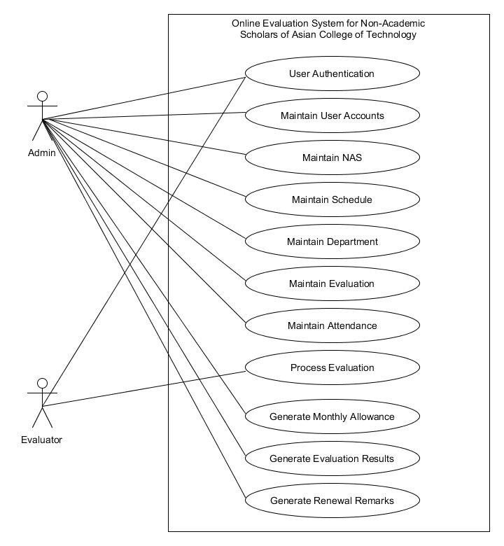

Figure 3: Business Use Case Model of OESNAS

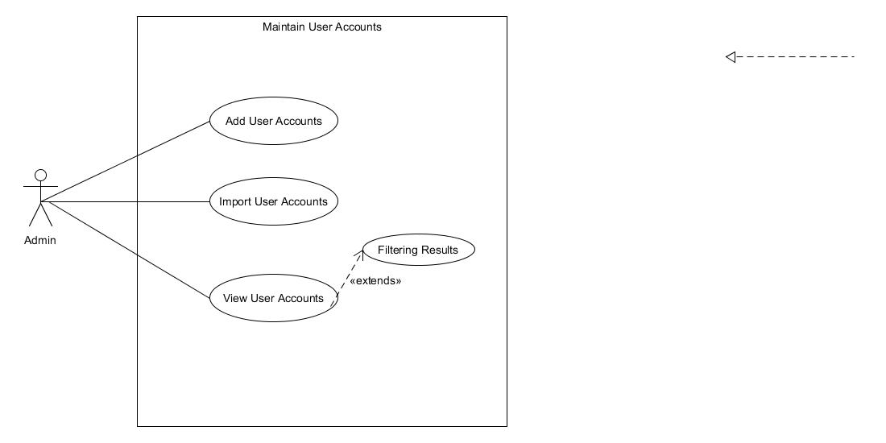

Figure : System User Case Of Maintain User Account in Admin

Figure 5: System Use Case of Maintain User Account in Admin

Use Case Description

Use Case name : Add User Account

Triggering Actor : Admin

Benefiting Actor : User

Purpose : To Add User Account

Pre-condition : The user clicks the add button

Post-condition : Successfully Added!

Steps

|  |  |
| --- | --- |
| Admin | System |
| 2. Input fields required | 1. Load Adding User Accounts page |
| 3. Click Add button | 4. Displays success message |

Use Case Description

Use Case name : Import User Accounts

Triggering Actor : Admin

Benefiting Actor : User

Purpose : To import user accounts

Pre-condition : The admin clicks the import button

Post-condition : Displays the number row inserted and failed.

Steps

|  |  |
| --- | --- |
| Admin | System |
| 2. Input fields needed | 1. Load Importing User Accounts page |
| 3. Click Import button | 4. Display rows inserted and rows failed |

Use Case Description

Use Case name : View User Accounts

Triggering Actor : Admin

Benefiting Actor : Admin

Purpose : View user accounts.

Pre-condition : The admin wants to view user accounts.

Post-condition : Display User accounts on a table.

Steps

|  |  |
| --- | --- |
| Admin | System |
| 1. Clicks the user account side navigation. | 2. Load user accounts result page. |

Use Case Description

Use Case name : Filtering Results

Triggering Actor : Admin

Benefiting Actor : Admin

Purpose : Filtering the results of viewing User Accounts.

Pre-condition : The admin wants to filter in viewing user accounts.

Post-condition : Display Filtered User accounts.

Steps

|  |  |
| --- | --- |
| Admin | System |
| 2. Select role or department. | 1. Load User Accounts page |
| 3. Click Import button | 4. Load User Accounts page with filtered results. |

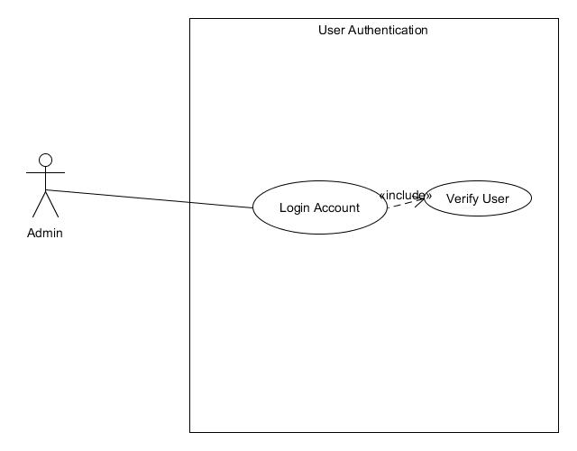

Figure 6: System User Case of User Authentication of Admin

Use Case Description

Use Case name : User Authentication

Triggering Actor : Admin/Evaluator

Benefiting Actor : Admin/Evaluator

Purpose : To login admin account

Pre-condition : The admin wants to login

Post-condition : Verify User

Steps

|  |  |
| --- | --- |
| Admin/Evaluator | System |
| 2. Input Username and Password | 1. Load Login UI |
| 3. Click Login button | 4. Verify credentials |

Use Case Description

Use Case name : Verify User

Triggering Actor : Admin/Evaluator

Benefiting Actor : Admin/Evaluator

Purpose : To verify admin account

Pre-condition : The admin clicks the login button

Post-condition : The admin successfully login

Steps

|  |  |
| --- | --- |
| Admin /Evaluator | System |
|  | 1. If admin’s credential are registered.  1.1 If user is verified  1.1.1 If user is admin  1.1.1.1 Load Admin Start UI  Else  1.1.1.2 Load Evaluator Home Page  Else  1.2 Show verification dialog.  Else  Show infobox “It looks like the credentials you've entered was not registered.” |

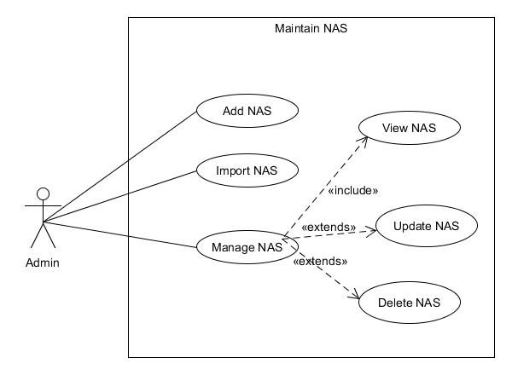

Figure 7: System User Case of Maintain NAS of Admin

Use Case Description

Use Case name : Add NAS

Triggering Actor : Admin

Benefiting Actor : Admin

Purpose : To add new NAS.

Pre-condition : The admin wants to add NAS.

Post-condition : Adding successful.

Steps

|  |  |
| --- | --- |
| Admin | System |
| 2. Input fields required | 1. Load Adding NAS page |
| 3. Click Add button | 4. Displays a success message |

Use Case Description

Use Case name : Import NAS

Triggering Actor : Admin

Benefiting Actor : Admin

Purpose : To add new NAS.

Pre-condition : The admin wants to add NAS.

Post-condition : Adding successful.

Steps

|  |  |
| --- | --- |
| Admin | System |
| 2. Input fields required | 1. Load Adding NAS page |
| 3. Click Add button | 4. Display a success message |

Use Case Description

Use Case name : Manage NAS

Triggering Actor : Admin

Benefiting Actor : Admin

Purpose : To manage NAS.

Pre-condition : The admin wants to manage NAS.

Post-condition : Adding successful.

Steps

|  |  |
| --- | --- |
| Admin | System |
| 2. Click manage button | 1. Loads all NAS page |
|  | 3. Load NAS Profile, Schedule, Attendance and Grade |

Use Case Description

Use Case name : View NAS

Triggering Actor : Admin

Benefiting Actor : Admin

Purpose : To view NAS.

Pre-condition : The admin wants to view NAS info.

Post-condition : The admin successfully viewed NAS info.

Steps

|  |  |
| --- | --- |
| Admin | System |
| 1. Clicks manage button |  |
|  | 2. Loads View NAS page |

Use Case Description

Use Case name : Update NAS

Triggering Actor : Admin

Benefiting Actor : Admin

Purpose : To update NAS.

Pre-condition : The admin wants to update NAS info.

Post-condition : The admin successfully updated NAS info.

Steps

|  |  |
| --- | --- |
| Admin | System |
|  | 1. Load update page for NAS |
| 2. Fill out fields to be updated |  |
| 3. Click Update button |  |
|  | 3. Display success message. |

Use Case Description

Use Case name : Delete NAS

Triggering Actor : Admin

Benefiting Actor : Admin

Purpose : To delete NAS.

Pre-condition : The admin wants to delete NAS info.

Post-condition : The admin successfully deleted NAS info.

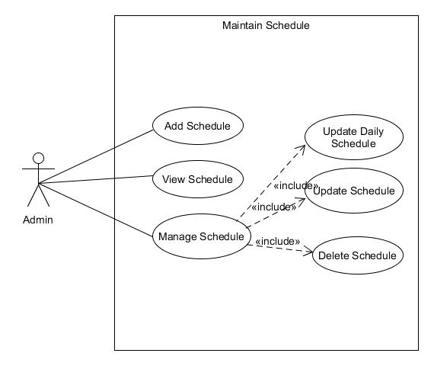Steps

Figure 8: System Use Case of Maintain Schedule of Admin

|  |  |
| --- | --- |
| Admin | System |
|  | 1. Load All NAS page |
| 2. Click delete button. |  |
|  | 3. Display success message |

Use Case Description

Use Case name : Add Schedule

Triggering Actor : Admin

Benefiting Actor : Admin

Purpose : To add schedule.

Pre-condition : The admin wants to add schedule.

Post-condition : The admin successfully added schedule.

Steps

|  |  |
| --- | --- |
| Admin | System |
|  | 1. Load Add Schedule page |
| 2. Fill out fields to be updated |  |
| 3. Click Add button |  |
|  | 3. Display success message |

Use Case Description

Use Case name : View Schedule

Triggering Actor : Admin

Benefiting Actor : Admin

Purpose : To view schedule.

Pre-condition : The admin wants to view schedule.

Post-condition : The admin successfully viewed schedule.

Steps

|  |  |
| --- | --- |
| Admin | System |
| 1. Clicks the manage schedule side navigation button |  |
|  | 2. Load View Schedule page |

Use Case Description

Use Case name : Manage Schedule

Triggering Actor : Admin

Benefiting Actor : Admin

Purpose : To manage schedule.

Pre-condition : The admin wants to manage schedule.

Post-condition : The admin successfully update, delete schedule.

Steps

|  |  |
| --- | --- |
| Admin | System |
| 1. Clicks the manage schedule side navigation button |  |
|  | 2. Load View Schedule page |
| 3. Clicks the Update button |  |
|  | 3. Load the Manage Schedule page |

Use Case Description

Use Case name : Update Daily Schedule

Triggering Actor : Admin

Benefiting Actor : Admin

Purpose : To update daily schedule.

Pre-condition : The admin wants to update daily schedule.

Post-condition : The admin successfully update daily schedule.

Steps

|  |  |
| --- | --- |
| Admin | System |
| 1. Clicks the daily schedule tab |  |
|  | 2. Load Daily Schedule page |
| 3. Clicks update button on the table |  |
|  | 3. Show update dialog. |
| 4. Input value and click update button. |  |
|  | 5. Display success message. |

Use Case Description

Use Case name : Update Schedule

Triggering Actor : Admin

Benefiting Actor : Admin

Purpose : To update schedule info.

Pre-condition : The admin wants to update schedule info.

Post-condition : The admin successfully updated schedule info.

Steps

|  |  |
| --- | --- |
| Admin | System |
| 1. Clicks the info tab |  |
|  | 2. Load Schedule Info page |
| 3. Clicks edit info button. |  |
|  | 3. Show edit schedule details dialog. |
| 4. Input value and click update button. |  |
|  | 5. Displays success message |

Use Case Description

Use Case name : Delete Schedule

Triggering Actor : Admin

Benefiting Actor : Admin

Purpose : To delete schedule info.

Pre-condition : The admin wants to delete schedule info.

Post-condition : The admin successfully deleted schedule info.

Steps

|  |  |
| --- | --- |
| Admin | System |
|  | 1. Load Manage Schedule page |
|  | 2. Load Schedule Info page |
| 3. Clicks edit info button. |  |
|  | 3. Show edit schedule details dialog. |
| 4. Input value and click update button. |  |
|  | 5. Displays a success message. |

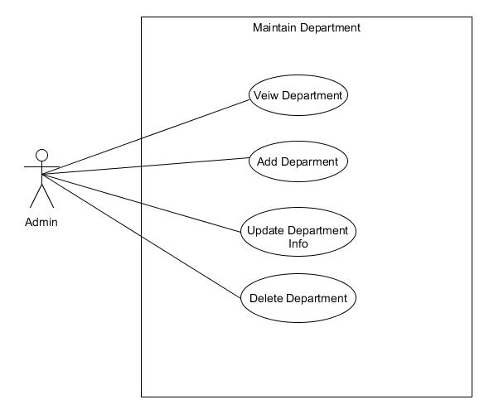

Figure 9: System Use Case of Maintain Department

Use Case Description

Use Case name : View Department

Triggering Actor : Admin

Benefiting Actor : Admin

Purpose : To view department.

Pre-condition : The admin wants to view department.

Post-condition : The admin viewed department.

Steps

|  |  |
| --- | --- |
| Admin | System |
| 1. Clicks the department side navigation button |  |
|  | 2. Load Department View page |

Use Case Description

Use Case name : Add Department

Triggering Actor : Admin

Benefiting Actor : Admin

Purpose : To add department.

Pre-condition : The admin wants to add department.

Post-condition : The admin added department successfully.

Steps

|  |  |
| --- | --- |
| Admin | System |
|  | 1. Load Department View page |
| 2. Clicks add new department button |  |
|  | 3. Show add department dialog |
| 4. Fill out all fields required and click add button. |  |
|  | 5. Display success message. |

Use Case Description

Use Case name : Update Department Info

Triggering Actor : Admin

Benefiting Actor : Admin

Purpose : To update department info.

Pre-condition : The admin wants update department info.

Post-condition : The admin updated department info successfully.

Steps

|  |  |
| --- | --- |
| Admin | System |
|  | 1. Load Department View page |
| 2. Clicks update button in the table |  |
|  | 3. Loads the manage department page |
| 4. Clicks the edit info button . |  |
|  | 5. Show Edit Info Dialog. |
| 6. Input fields to be updated and click update button |  |
|  | 7. Display success message. |

Use Case Description

Use Case name : Delete department

Triggering Actor : Admin

Benefiting Actor : Admin

Purpose : To delete department.

Pre-condition : The admin wants to delete department.

Post-condition : The admin deleted department.

Steps

|  |  |
| --- | --- |
| Admin | System |
|  | 1. Load Department View page |
| 2. Clicks delete button in the table |  |
|  | 3. Display success message. |

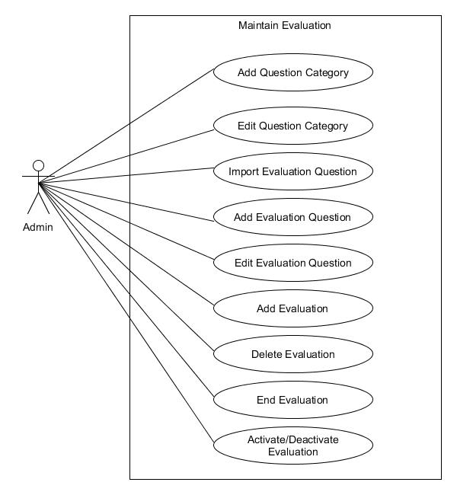

Figure 10: System Use Case of Maintain Evaluation

Use Case Description

Use Case name : Add Question Category

Triggering Actor : Admin

Benefiting Actor : Admin

Purpose : To add question category.

Pre-condition : The admin wants to add question category.

Post-condition : The admin successfully added question category.

Steps

|  |  |
| --- | --- |
| Admin | System |
|  | 1. Loads the question category view page |
| 2. Clicks the add button |  |
|  | 3. Show the add question category dialog |
| 4. Input fields required and click add button |  |
|  | 5. Display success message |

Use Case Description

Use Case name : Edit Question Category

Triggering Actor : Admin

Benefiting Actor : Admin

Purpose : To edit question category.

Pre-condition : The admin wants to edit question category.

Post-condition : The admin successfully edit question category.

Steps

|  |  |
| --- | --- |
| Admin | System |
|  | 1. Loads the question category view page |
| 2. Clicks the edit button in the table |  |
|  | 3. Show the edit question category dialog |
| 4. Input fields and click update button |  |
|  | 5. Display success message |

Use Case Description

Use Case name : Import Evaluation Question

Triggering Actor : Admin

Benefiting Actor : Admin

Purpose : To import evaluation question.

Pre-condition : The admin wants to import evaluation questions.

Post-condition : The admin successfully imported evaluation questions.

Steps

|  |  |
| --- | --- |
| Admin | System |
|  | 1. Loads the evaluation question view page |
| 2. Clicks the import button |  |
|  | 3. Loads the import evaluation page |
| 4. Choose excel file from the file browser button |  |
|  | 5. Display excel content into the table |
| 6. Click import button |  |
|  | 6. Display success message |

Use Case Description

Use Case name : Add Evaluation Question

Triggering Actor : Admin

Benefiting Actor : Admin

Purpose : To add evaluation question.

Pre-condition : The admin wants to add evaluation questions.

Post-condition : The admin successfully added evaluation questions.

Steps

|  |  |
| --- | --- |
| Admin | System |
|  | 1. Loads the evaluation question view page |
| 2. Clicks the add button |  |
|  | 3. Shows add evaluation question dialog |
| 4. Input fields required and click the add button |  |
|  | 5. Display success message |

Use Case Description

Use Case name : Edit Evaluation Question

Triggering Actor : Admin

Benefiting Actor : Admin

Purpose : To edit evaluation question.

Pre-condition : The admin wants to edit evaluation questions.

Post-condition : The admin successfully edited evaluation questions.

Steps

|  |  |
| --- | --- |
| Admin | System |
|  | 1. Loads the evaluation question view page |
| 2. Clicks the edit button in the table |  |
|  | 3. Show edit evaluation question dialog |
| 4. Input values and click update button |  |
|  | 5. Display success message |

Use Case Description

Use Case name : Add Evaluation

Triggering Actor : Admin

Benefiting Actor : Admin

Purpose : To add evaluation question.

Pre-condition : The admin wants to add evaluation.

Post-condition : The admin successfully added evaluation.

Steps

|  |  |
| --- | --- |
| Admin | System |
|  | 1. Loads the evaluation view page |
| 2. Clicks the add new button |  |
|  | 3. Shows add new evaluation dialog |
| 4. Input fields required and click add button |  |
|  | 5. Display success message |

Use Case Description

Use Case name : Delete Evaluation

Triggering Actor : Admin

Benefiting Actor : Admin

Purpose : To delete evaluation question.

Pre-condition : The admin wants to delete evaluation.

Post-condition : The admin successfully deleted evaluation.

Steps

|  |  |
| --- | --- |
| Admin | System |
|  | 1. Loads the evaluation view page |
| 2. Clicks the delete button on the table |  |
|  | 3. Shows delete confirmation dialog |
| 4. Clicks delete |  |
|  | 5. Display success message |

Use Case Description

Use Case name : End evaluation

Triggering Actor : Admin

Benefiting Actor : Admin

Purpose : To end evaluation.

Pre-condition : The admin wants to end evaluation.

Post-condition : The admin successfully ended evaluation.

Steps

|  |  |
| --- | --- |
| Admin | System |
|  | 1. Loads the evaluation view page |
| 2. Clicks the monitor button on the table |  |
|  | 3. Loads Monitor Evaluation page |
| 4. Clicks end evaluation button |  |
|  | 5. Refresh page |

Use Case Description

Use Case name : Activate/Deactivate evaluation

Triggering Actor : Admin

Benefiting Actor : Admin

Purpose : To activate/deactivate evaluation.

Pre-condition : The admin wants to end evaluation.

Post-condition : The admin successfully ended evaluation.

Steps

|  |  |
| --- | --- |
| Admin | System |
|  | 1. Loads the evaluation view page |
| 2. Clicks the monitor button on the table |  |
|  | 3. Loads Monitor Evaluation page |
| 4. Clicks activate/deactivate swicth button |  |
|  | 5. Refresh page |

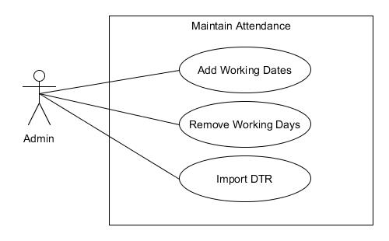

Figure 11: System Use Case of Maintain Attendance

Use Case Description

Use Case name : Add Working Dates

Triggering Actor : Admin

Benefiting Actor : Admin

Purpose : To add working dates.

Pre-condition : The admin wants to add working dates.

Post-condition : The admin successfully added working days.

Steps

|  |  |
| --- | --- |
| Admin | System |
| 1. Clicks working days side navigation button |  |
|  | 2. Loads working dates page. |
| 3. Clicks the add button |  |
|  | 4. Shows the add working dates dialog |
| 5. Inputs required fields and select dates from the calendar. |  |
|  | 5. Refresh page. |

Use Case Description

Use Case name : Remove Working Dates

Triggering Actor : Admin

Benefiting Actor : Admin

Purpose : To remove working dates.

Pre-condition : The admin wants to remove working dates.

Post-condition : The admin successfully removed working days.

Steps

|  |  |
| --- | --- |
| Admin | System |
| 1. Clicks working days side navigation button |  |
|  | 2. Loads working dates page. |
| 3. Clicks the remove button from the table |  |
|  | 4. Displays success message. |

Use Case Description

Use Case name : Import DTR

Triggering Actor : Admin

Benefiting Actor : Admin

Purpose : To import DTR.

Pre-condition : The admin wants to import DTR.

Post-condition : The admin successfully imported DTR.

Steps

|  |  |
| --- | --- |
| Admin | System |
| 1. Clicks DTR side navigation button |  |
|  | 2. Loads DTR page. |
| 3. Clicks the import button |  |
|  | 4. Shows import DTR dialog |
| 5. Fill out all required fields, select excel file from the file browser and clicks import |  |
|  | 6. Refresh page. |

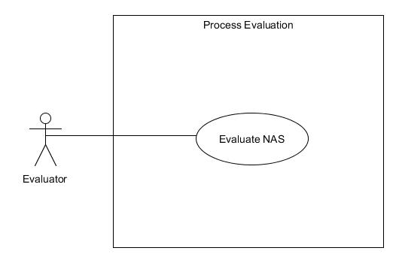

Figure 12: Use Case of Process Evaluation

Use Case Description

Use Case name : Evaluate NAS

Triggering Actor : Evaluator

Benefiting Actor : Evaluator

Purpose : To evaluate NAS.

Pre-condition : The evaluator wants to evaluate NAS.

Post-condition : The admin successfully evaluated NAS.

Steps

|  |  |
| --- | --- |
| Evaluator | System |
|  | 1. Loads evaluator home page |
| 2. Clicks evaluate button in the table |  |
|  | 3. Loads the evaluation page |
| 4. Answer all the evaluation questions and clicks submit button. |  |
|  | 5. Shows confirmation dialog. |
| 6. Clicks submit confirmation button |  |
|  | 7. Loads evaluator home page |

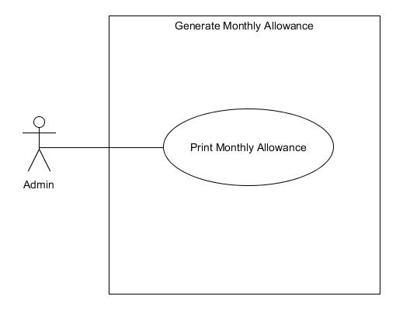

Figure 13: System Use Case of Generate Monthly Allowance

Use Case Description

Use Case name : Print Monthly Allowance

Triggering Actor : Admin

Benefiting Actor : Admin

Purpose : To print monthly allowance.

Pre-condition : The admin wants to print monthly allowance.

Post-condition : The admin successfully printed montly allowance.

Steps

|  |  |
| --- | --- |
| Admin | System |
| 1. Clicks monthly allowance side navigation button |  |
|  | 2. Loads monthly allowance page. |
| 3. Select school year, semester and month and clicks the print button |  |
|  | 4. Shows print dialog |
| 5. Clicks print button in the print dialog |  |
|  | 6. Prints the monthly allowance result |

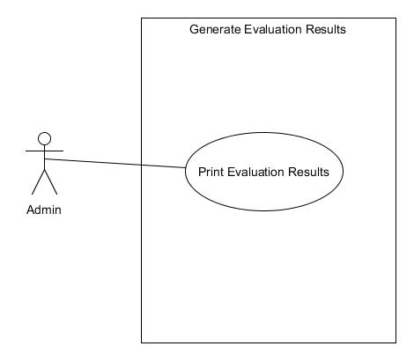

Figure 14: System Use Case of Generate Evaluation Results

Use Case Description

Use Case name : Print Evaluation Results

Triggering Actor : Admin

Benefiting Actor : Admin

Purpose : To print evaluation results.

Pre-condition : The admin wants to print evaluation results.

Post-condition : The admin successfully printed evaluation results.

Steps

|  |  |
| --- | --- |
| Admin | System |
| 1. Clicks evaluation results side navigation button |  |
|  | 2. Loads evaluation results page. |
| 3. Clicks view results to the chosen evaluation in the table |  |
|  | 4. Show NAS evaluation results page |
| 5. Clicks view report button in the table |  |
|  | 6. Loads NAS Evaluation Report page |
| 7. Clicks print button |  |
|  | 8. Shows print dialog |
| 9. Clicks print button in print dialog |  |
|  | 10. Prints the evaluation results |

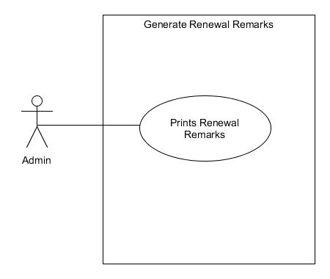

Figure 15: System Use Case of Generate Renewal Remarks

Use Case Description

Use Case name : Print Renewal Remarks

Triggering Actor : Admin

Benefiting Actor : Admin

Purpose : To print renewal remarks.

Pre-condition : The admin wants to print renewal remarks.

Post-condition : The admin successfully printed evaluation results.

Steps

|  |  |
| --- | --- |
| Admin | System |
| 1. Clicks renewal remarks side navigation button |  |
|  | 2. Loads renewal remarks page. |
| 3. Selects Schoolyear , semester and clicks print button. |  |
|  | 4. Shows print dialog |
| 5. Clicks print button in the print dialog |  |
|  | 6. Prints the renewal remarks |

### The Class Model

The illustration below is a class diagram which shows the structure of the proposed system by showing the system’s classes, their attributes, operations (or methods) and the relationships among objects.

Figure 16: Class Model of the System

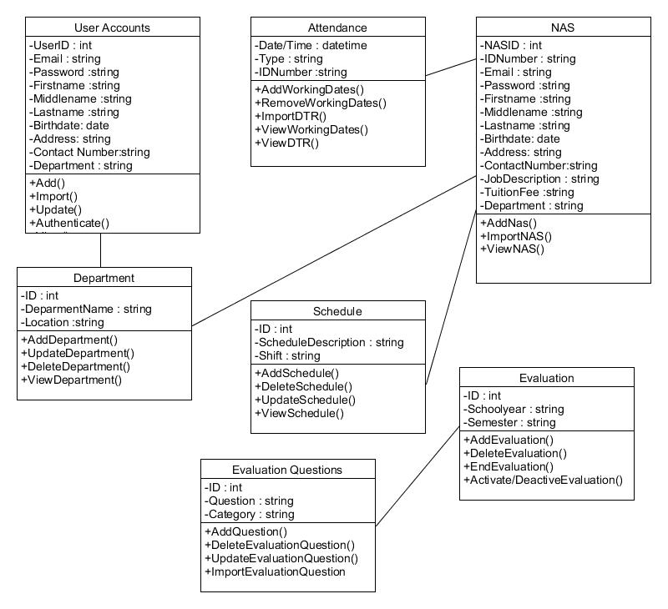

### Component Model

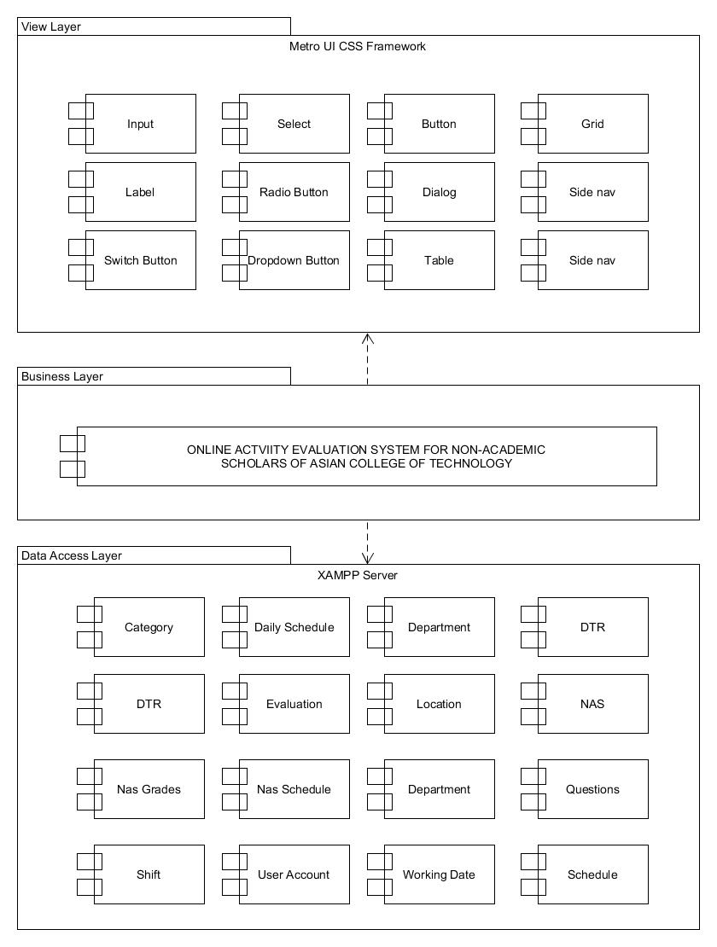The component diagram below models and shows the implementation and is used to represent or illustrate the structure of logical compound systems. It infers and depicts how components in the system are wired together to form larger components of software systems.

Figure 17: The Component Model of Online Evaluation System for Non-Academic Scholars of Asian College of Technology

### Deployment Model

The Model below shows the deployment diagram of the system that involves the hardware together with the use of the software components which works a system in the real industry transactions.

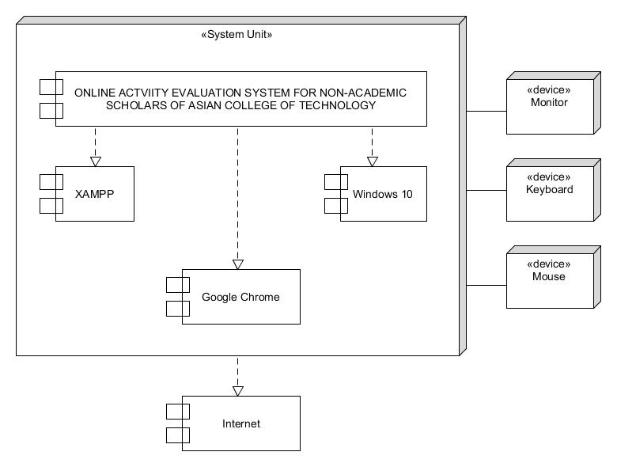

Figure 18: The Deployment Diagram of Online Evaluation System for Non-Academic Scholars of Asian College of Technology

### Implementation Strategies

Once the system has been completely developed and prepared to be implemented, the researchers will fully review the system as how to operate the system. When the system is completely developed, implementation is to be done. Upon the implementation, the Admin can now operate the system as well as the evaluator.

If the Asian College of Technology is satisfied and wants to impose the system, the researchers will make the system productive, reliable, secured, and development- ready in a web-based that can be used without any odds.

# Chapter 4

## DESIGN OF THE PROTOTYPE

### The User Interface

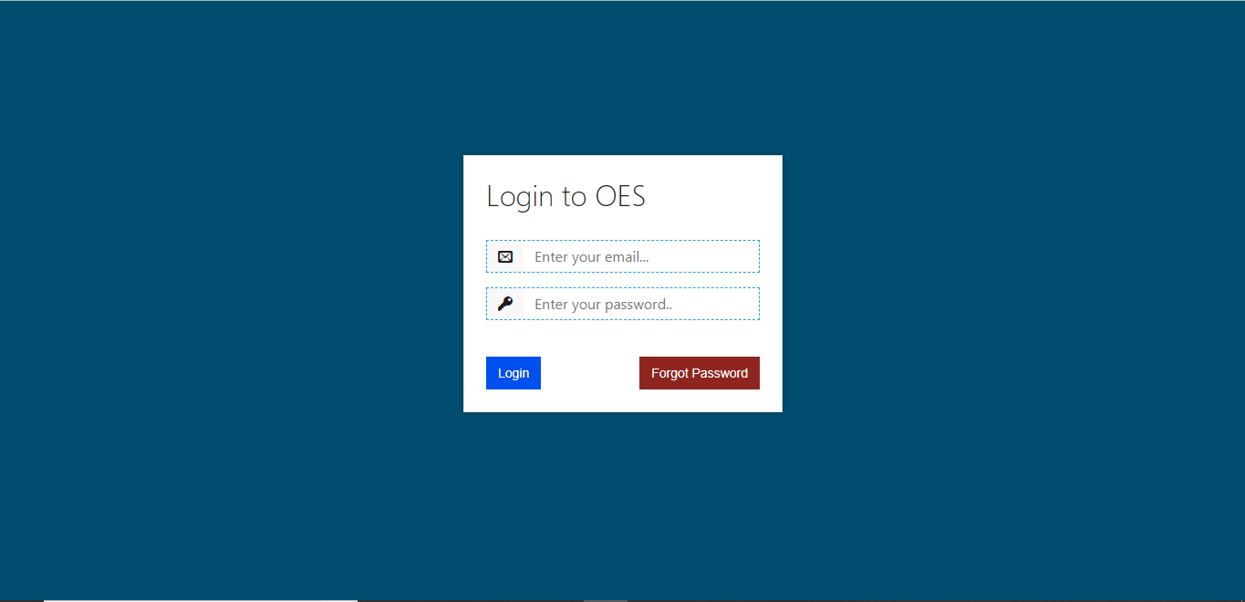

Figure 19: Login Page

Description: This is the admin and evaluator authentication page where they must enter their credentials to gain access of the system.

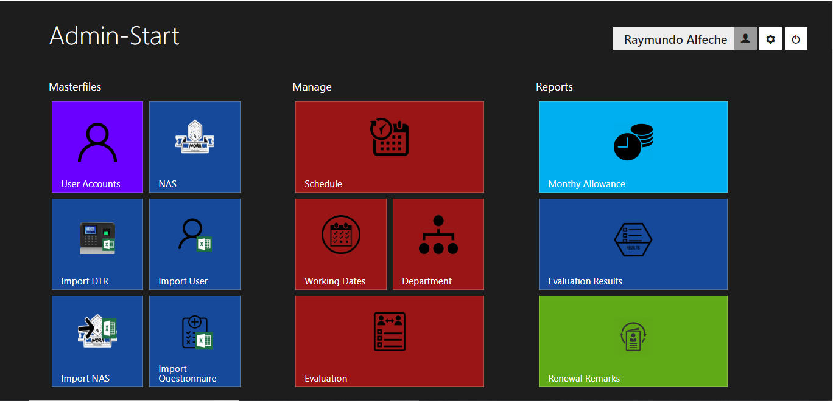

Figure 20: Admin Start Page

Description: This is called Admin-Start where the admin’s landing page after login in. This also serve as the homepage for the admin.

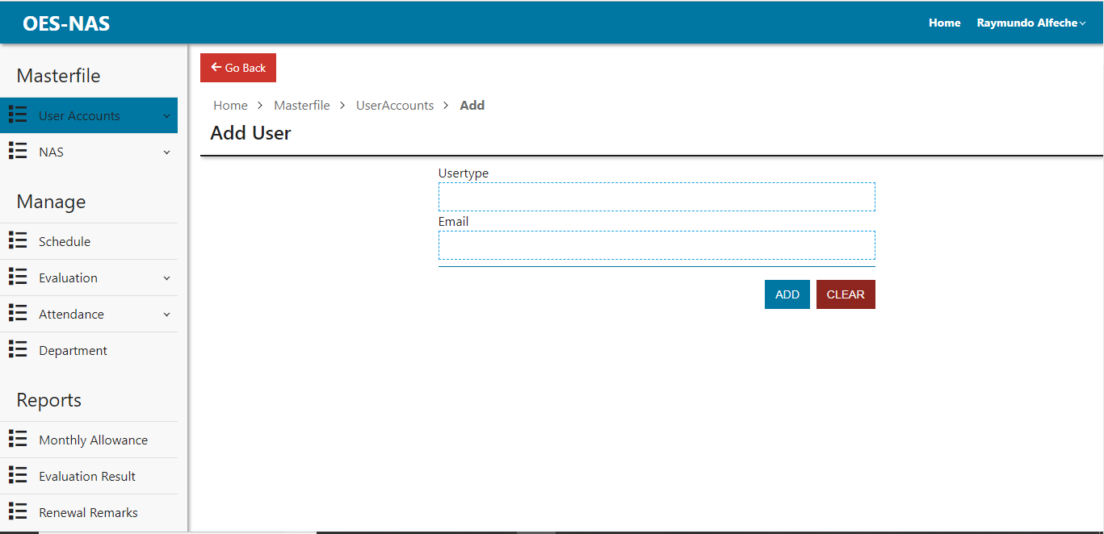

Figure 21: Adding of User page

Description: This page allows the admin to add a user for the system.

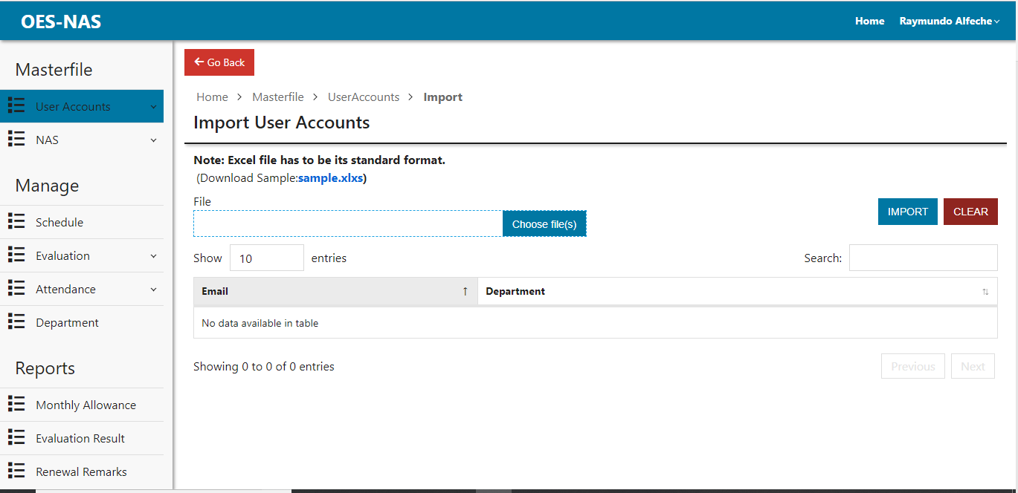

Figure 22: Importing of user page

Description: This page allows the admin to import user accounts from excel file.

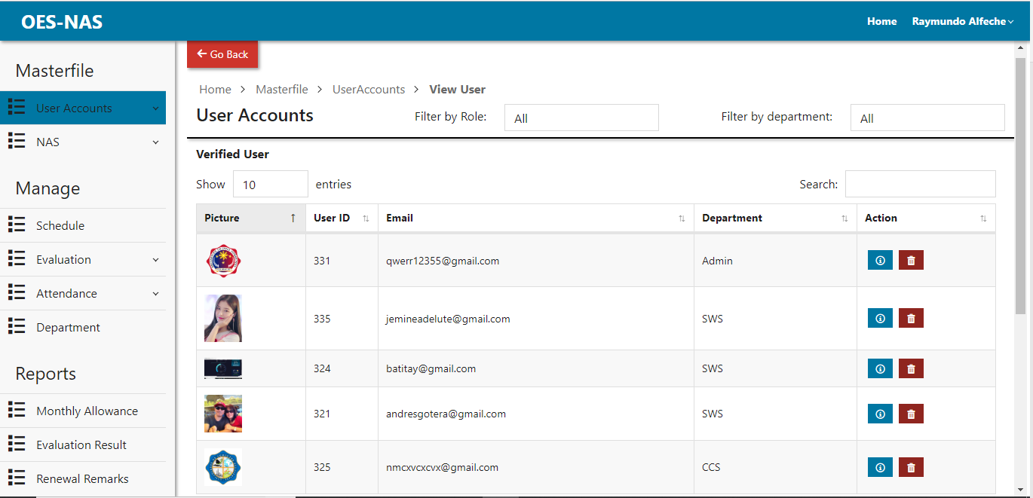

Figure 23: Viewing of user page

Description: This page is where the admin can view Verified and Unverified user.

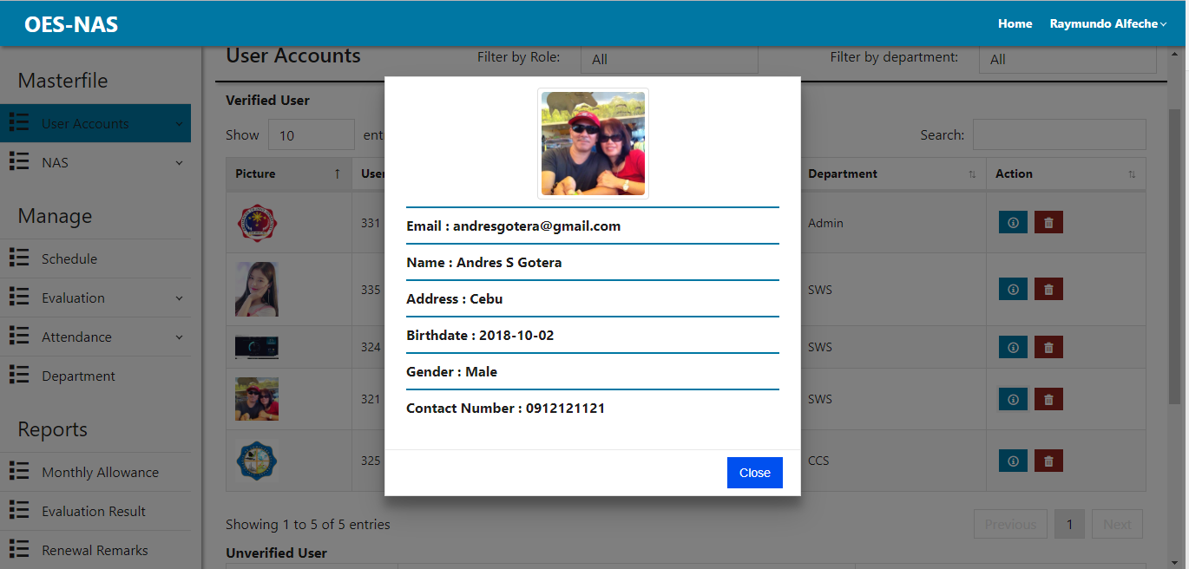

Figure 24: Viewing of user's information dialog

Description: This page allows the admin to view user’s information in.

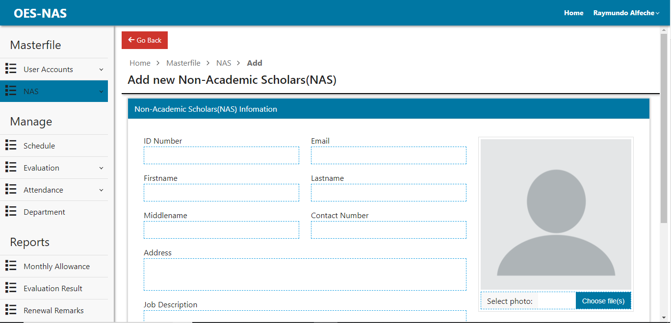

Figure 25: Adding of nas page

Description: This page is where the admin can add new nas.

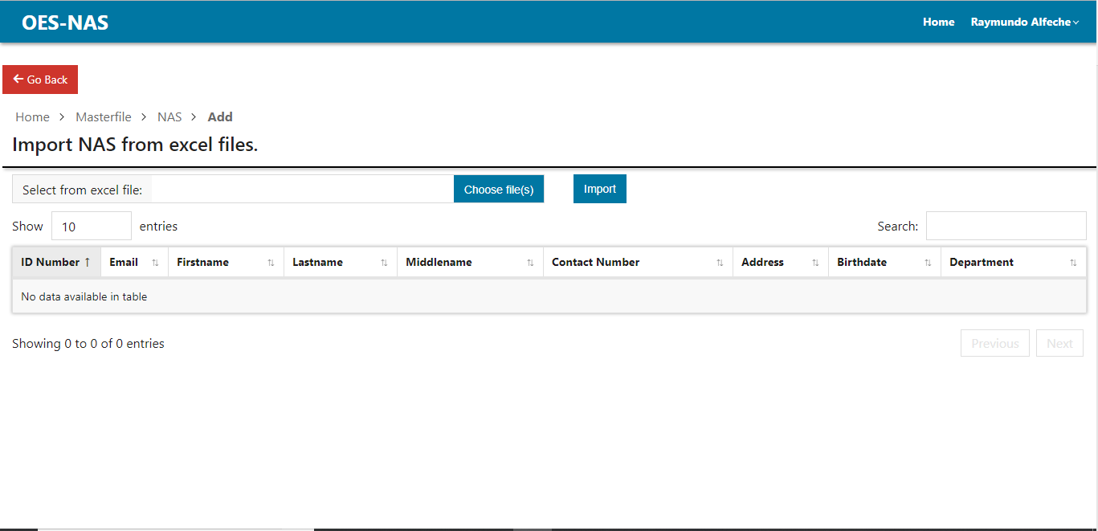

Figure 26: Importing of NAS page

Description: This page is where the admin can import NAS from excel files.

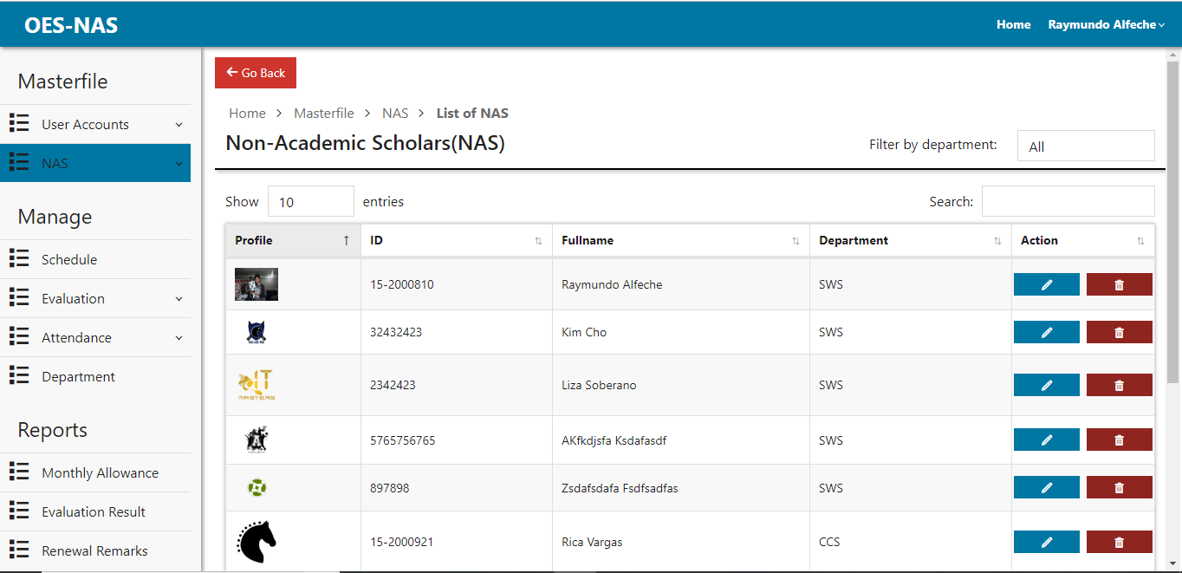

Figure 27: Viewing all NAS page.

Description: This is where the admin can view and manage all NAS.

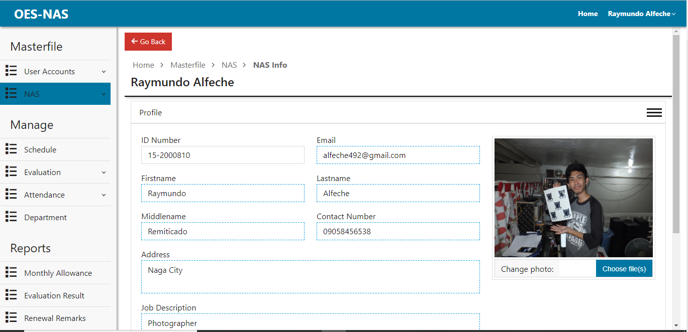

Figure 28: NAS profile page.

Description: This page is where the admin can view and update profile.

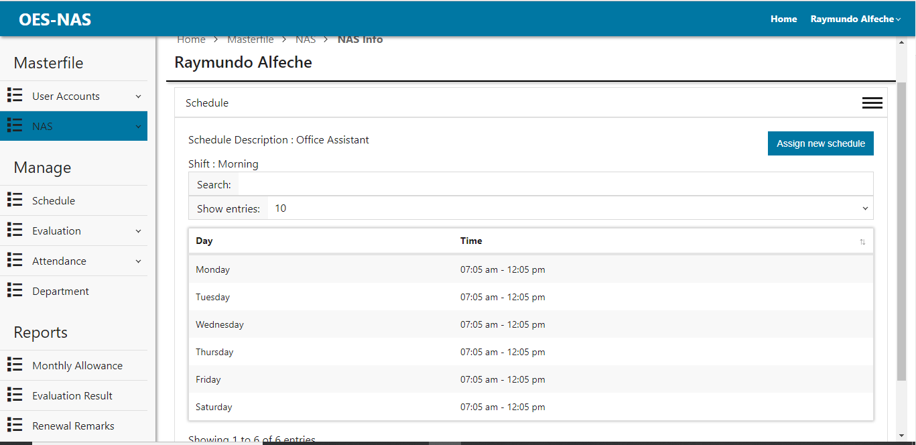

Figure 29: NAS Schedule page

Description: This page is where the admin can view and assign NAS schedule.

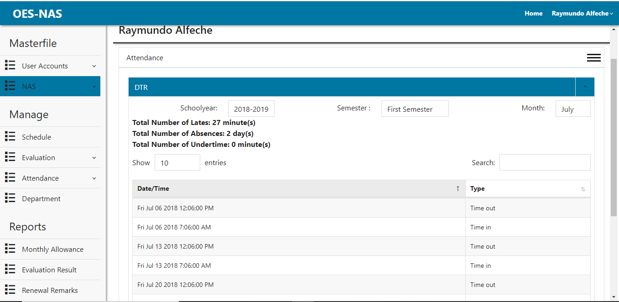

Figure 30: NAS Attendance page

Description: This page is where the admin can view NAS attendance.

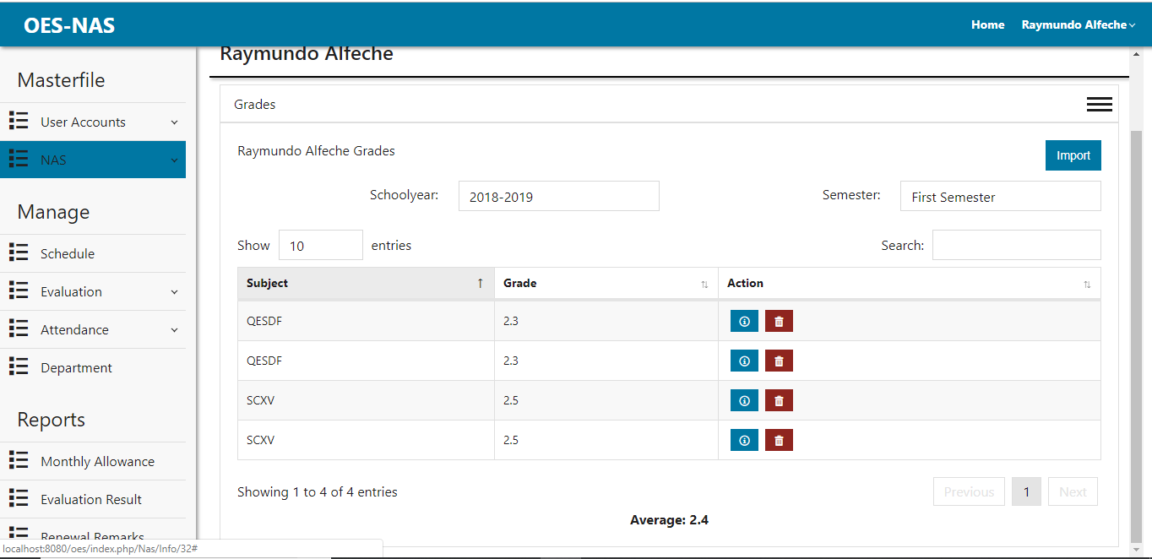

Figure 31: NAS Grade page

Description: This page is where the admin can add new nas.

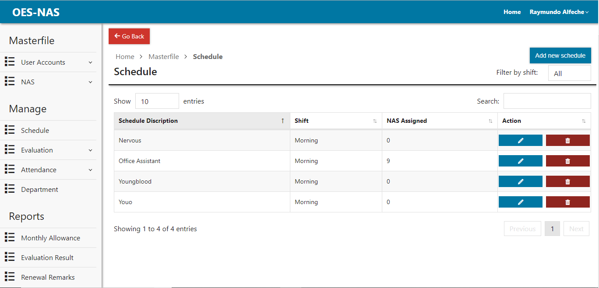

Figure 32: Schedule page.

Description: This page is where the admin can view, delete and add new schedule.

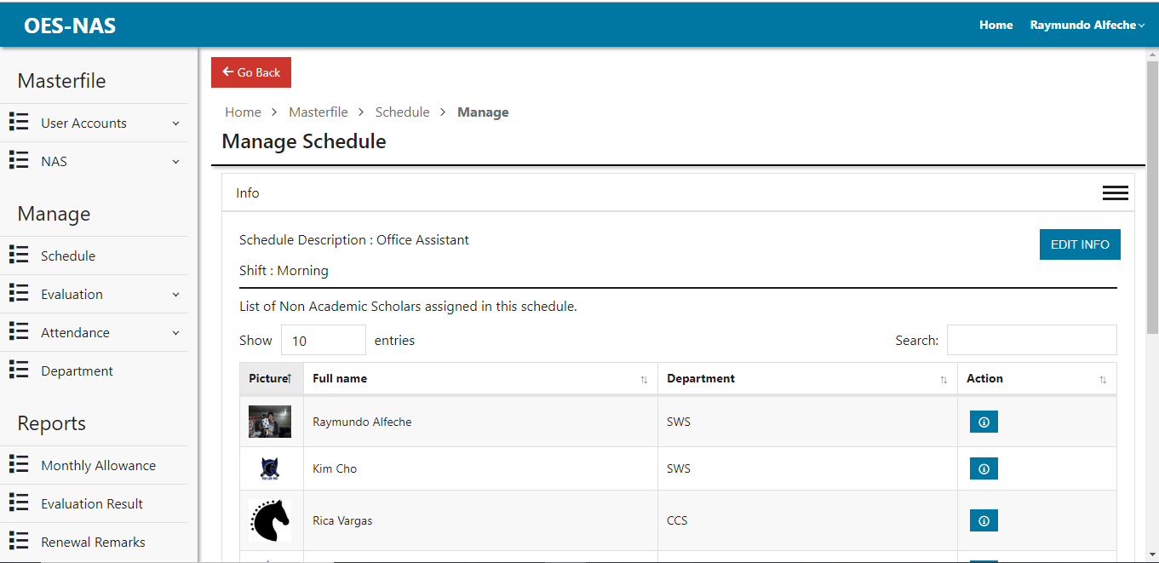

Figure 33: Manage schedule info page

Description: This page is where the admin can edit and view schedule information.

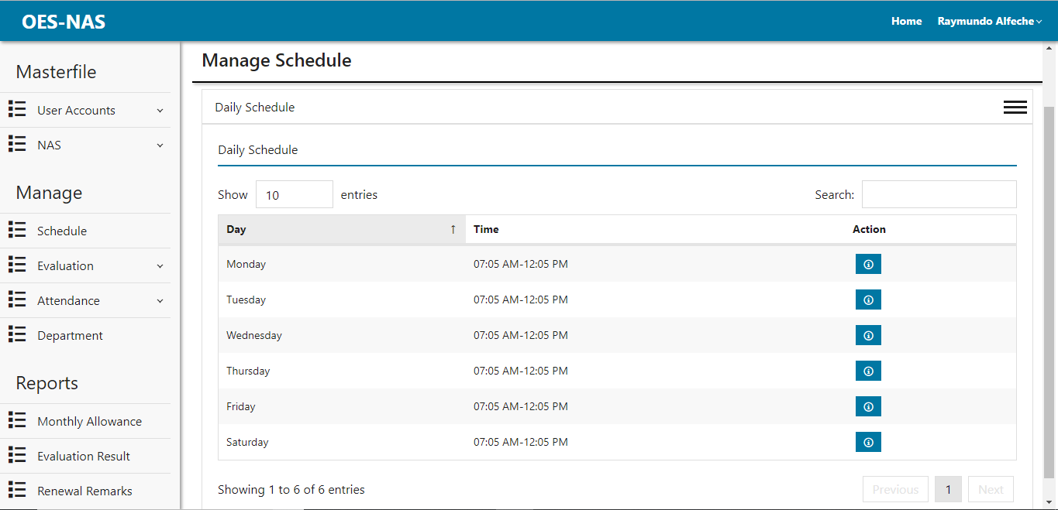

Figure 34: Daily Schedule Page

Description: This page is where the admin can view and edit daily schedule.

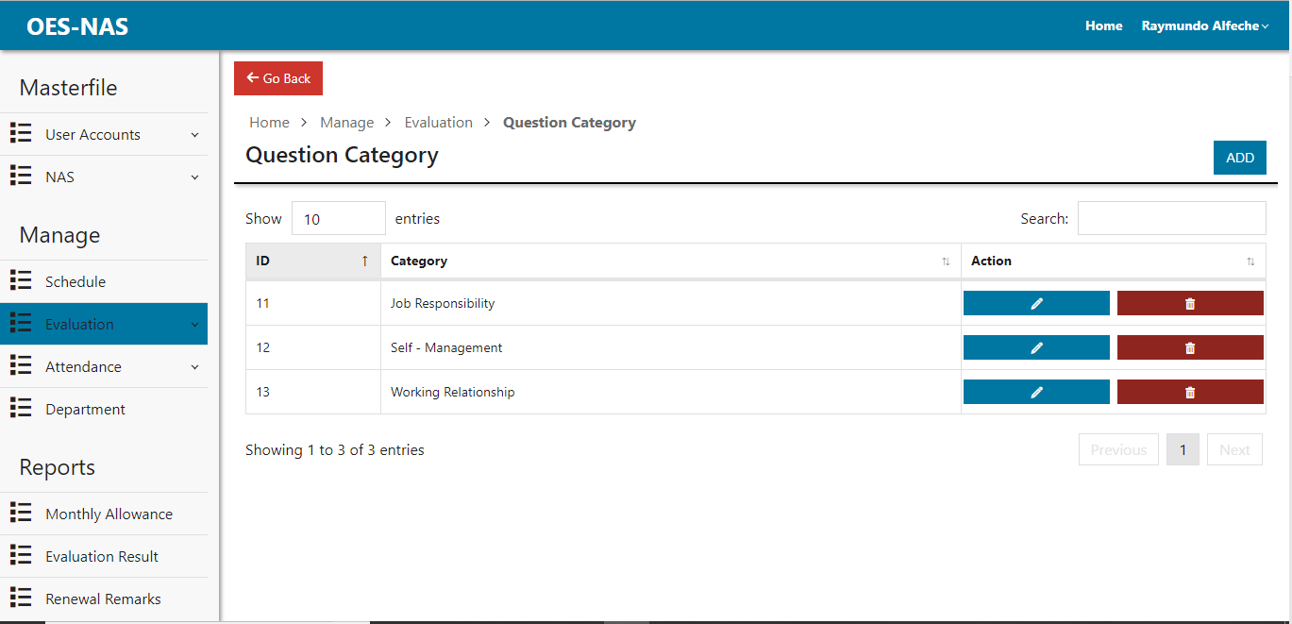

Figure 35: Question Category page.

Description: This page is where the admin can view, add, edit and delete question category that will when adding evaluation question.

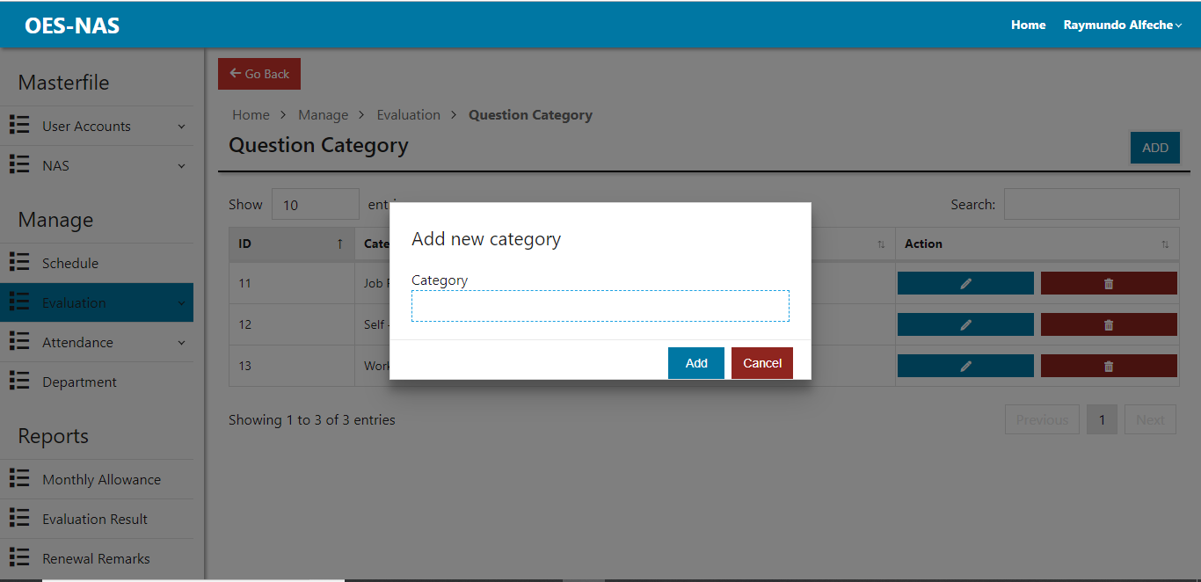

Figure 36: Adding of question category dialog

Description: This dialog is where the admin can add new category for the evaluation questions.

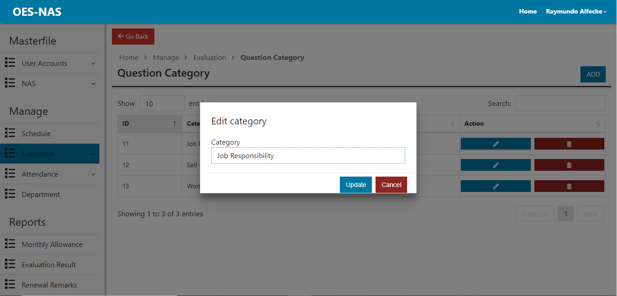

Figure 37: Edit category dialog

Description: This dialog is where the admin can edit category for the evaluation questions.

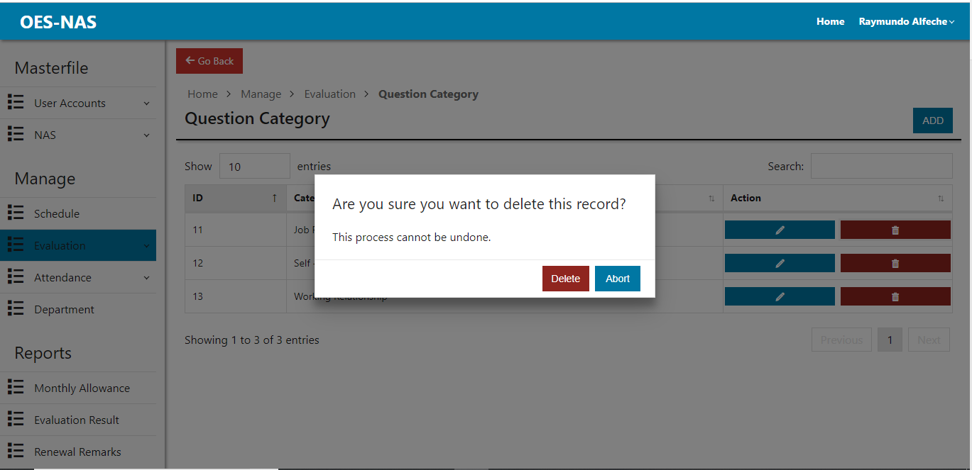

Figure 38: Confirm Category Deletion Dialog

Description: This dialog is where the admin confirms the deletion of the category.

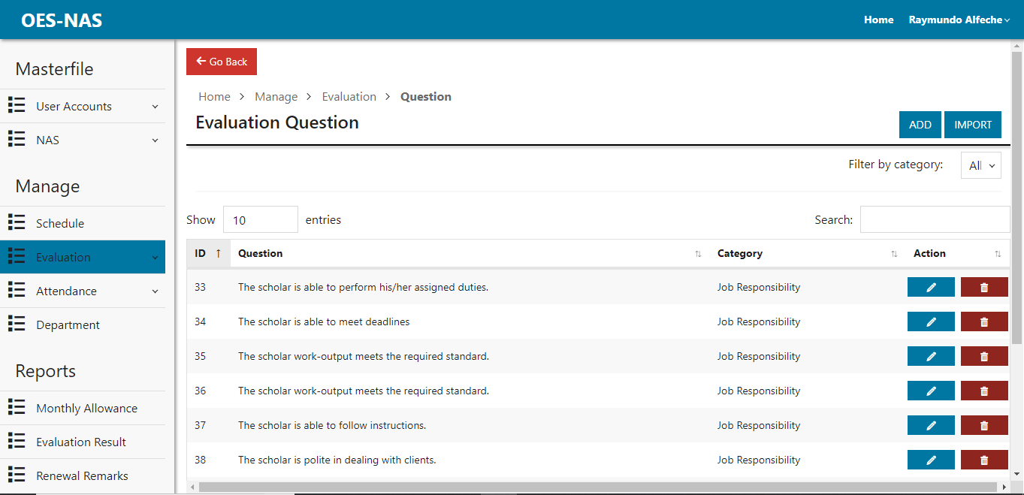

Figure 39: Evaluation Question Page

Description: This page is where the admin can add, view, edit and delete evaluation questions.

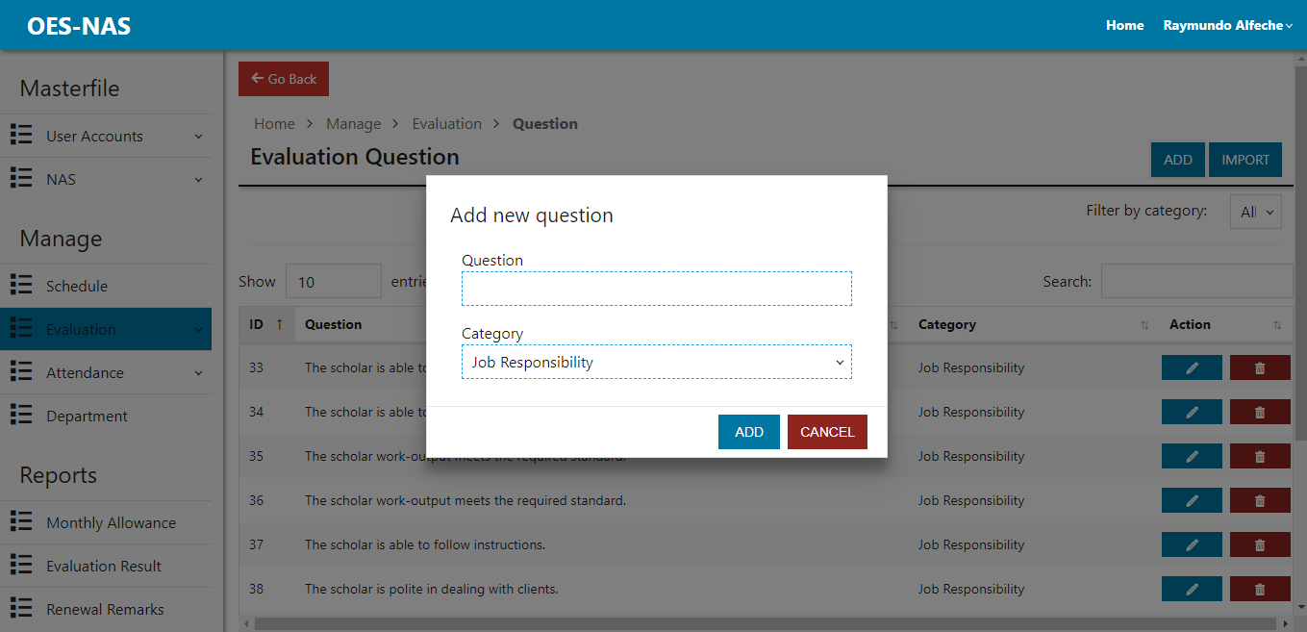

Figure 40: Add Question Dialog

Description: This dialog is where the admin can add new evaluation question.

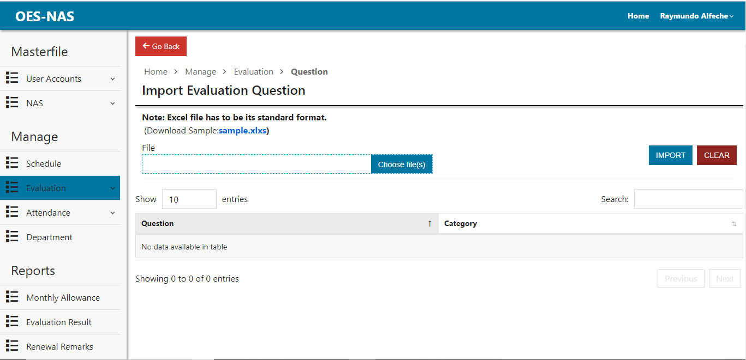

Figure 41: Importing Evaluation Question

Description: This page is where the admin can import evaluation question from excel files.

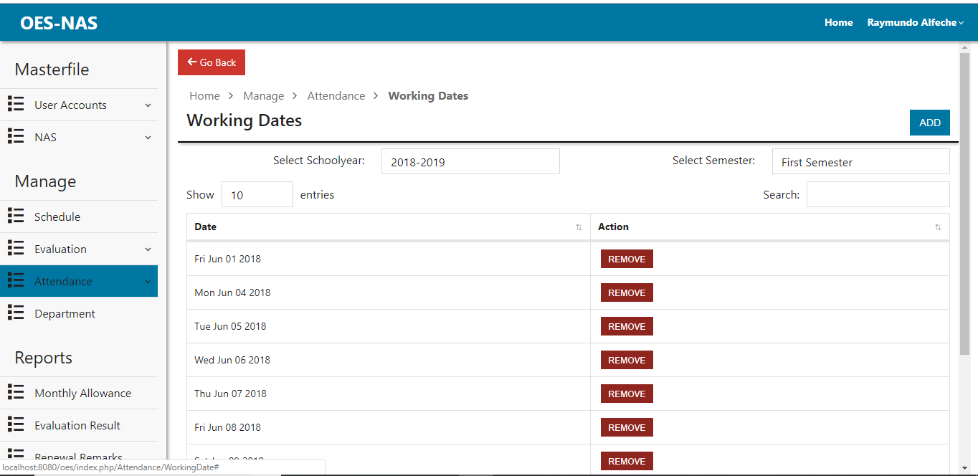

Figure 42: Working Dates Page

Description: This page is where the admin can view, add and remove working dates for the NAS.

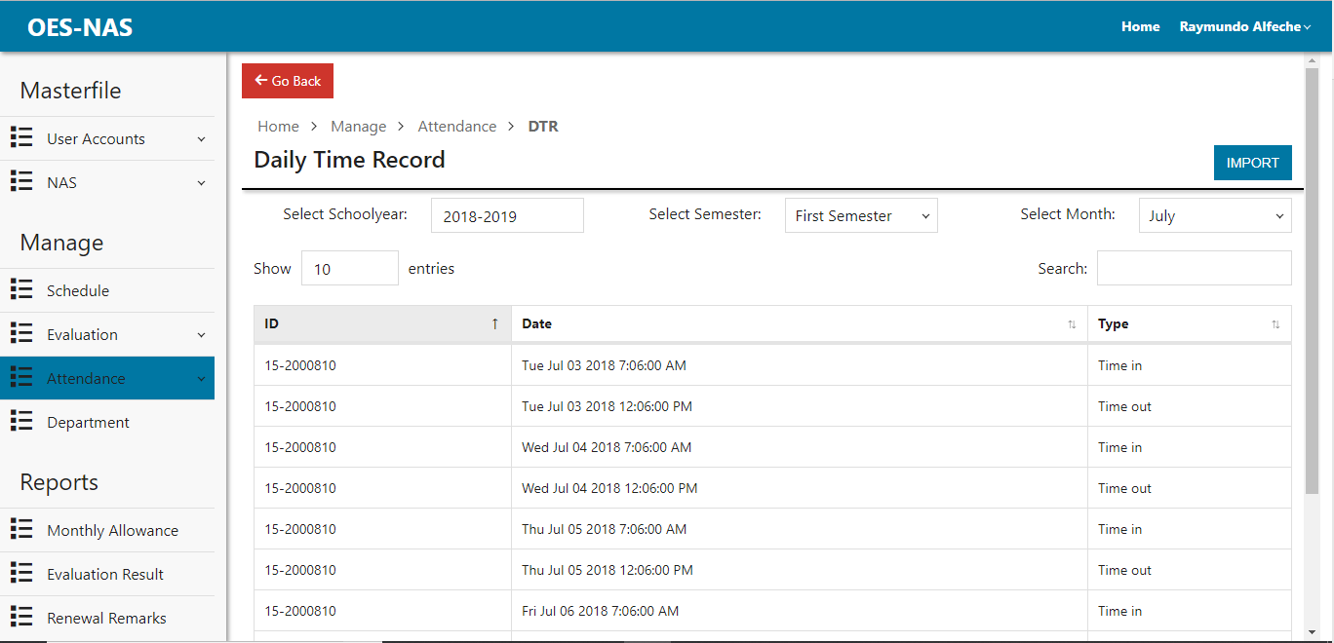

Figure 43: Daily Time Record Page

Description: This page is where the admin can view and import DTR for the attendance.

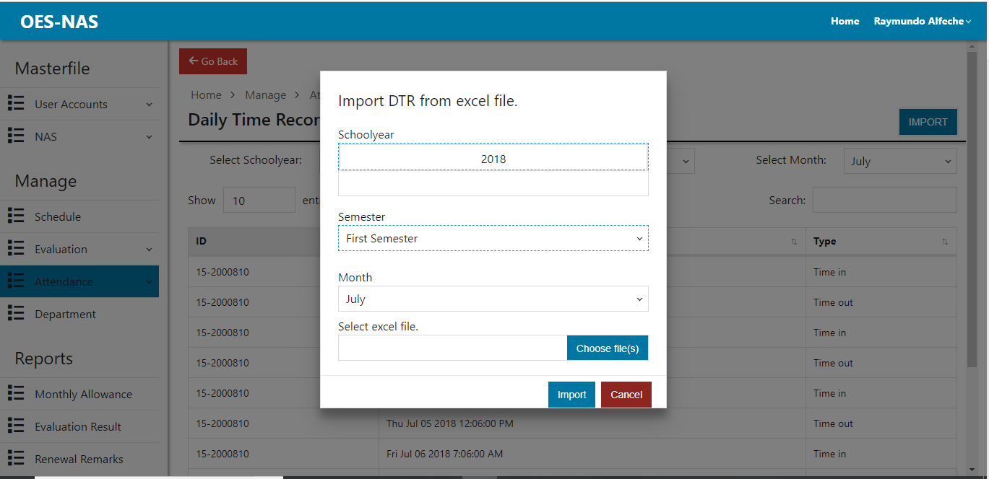

Figure 44: Import DTR Dialog

Description: This dialog is where the Importing of DTR from excel files happens.

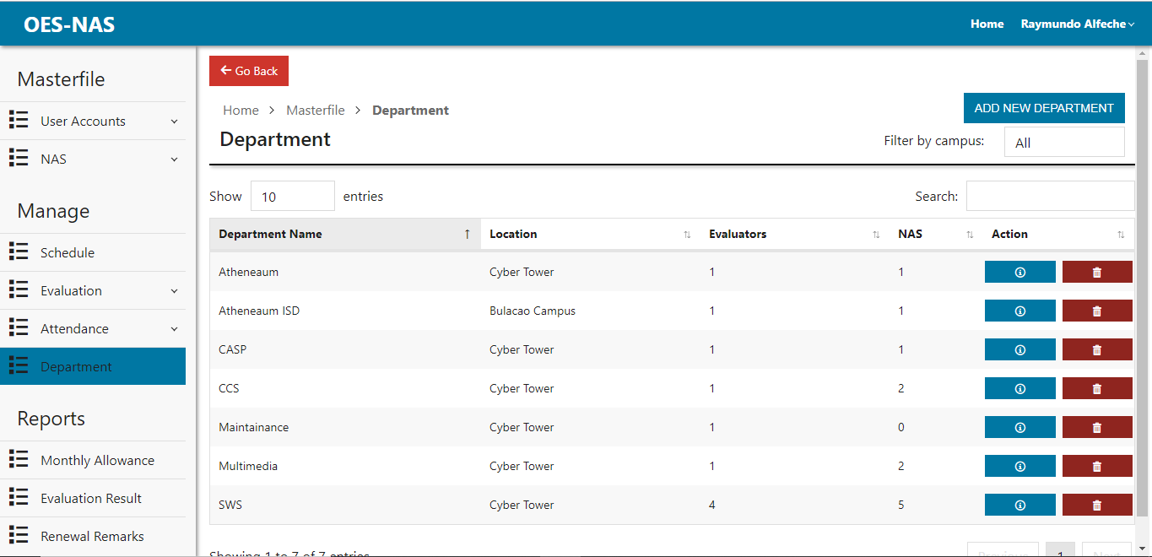

Figure 45: Department Page

Description: This page is where the admin can view, add, edit and delete department.

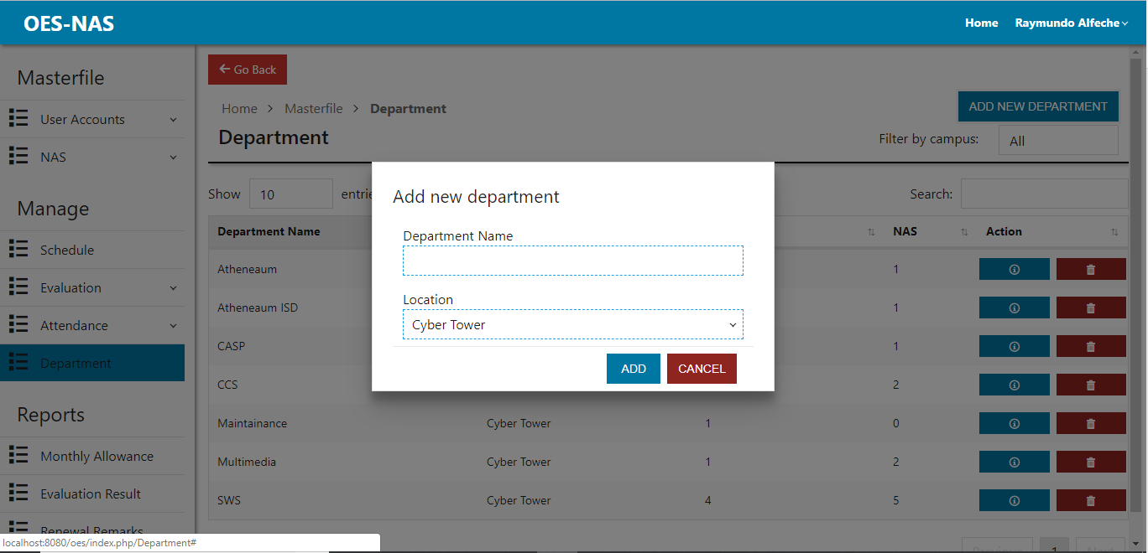

Figure 46: Adding New Department Dialog

Description: This dialog lets admin add new department.

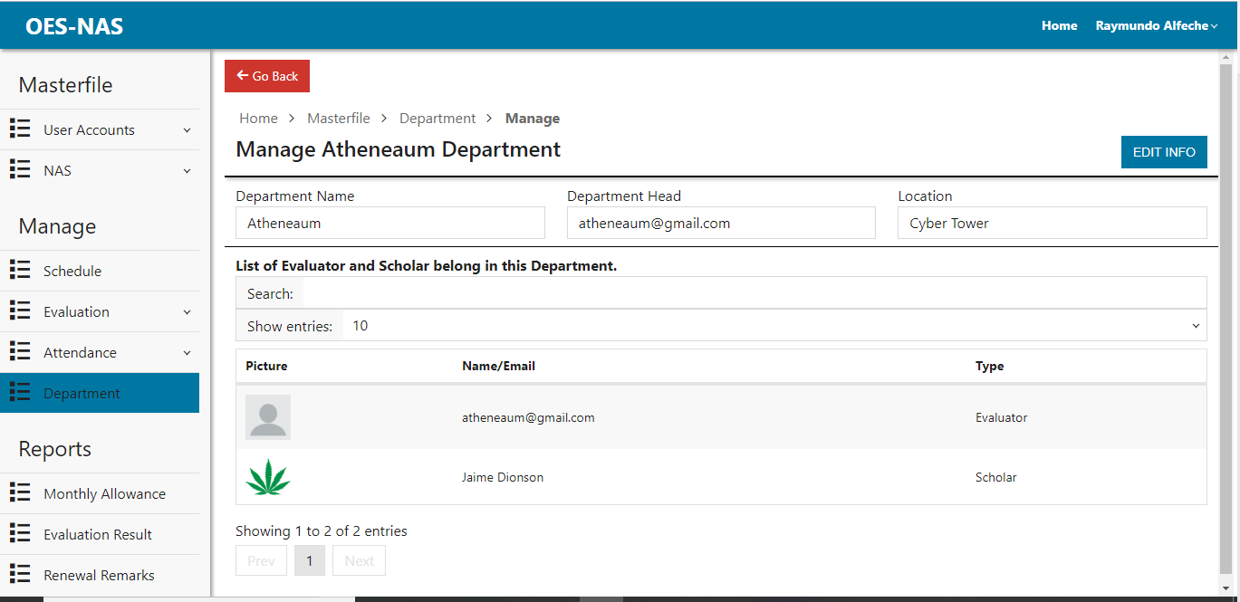

Figure 47: Edit Department Page

Description: This page allows the admin view department information ,evaluator and NAS in the department. The admin can also edit department info.

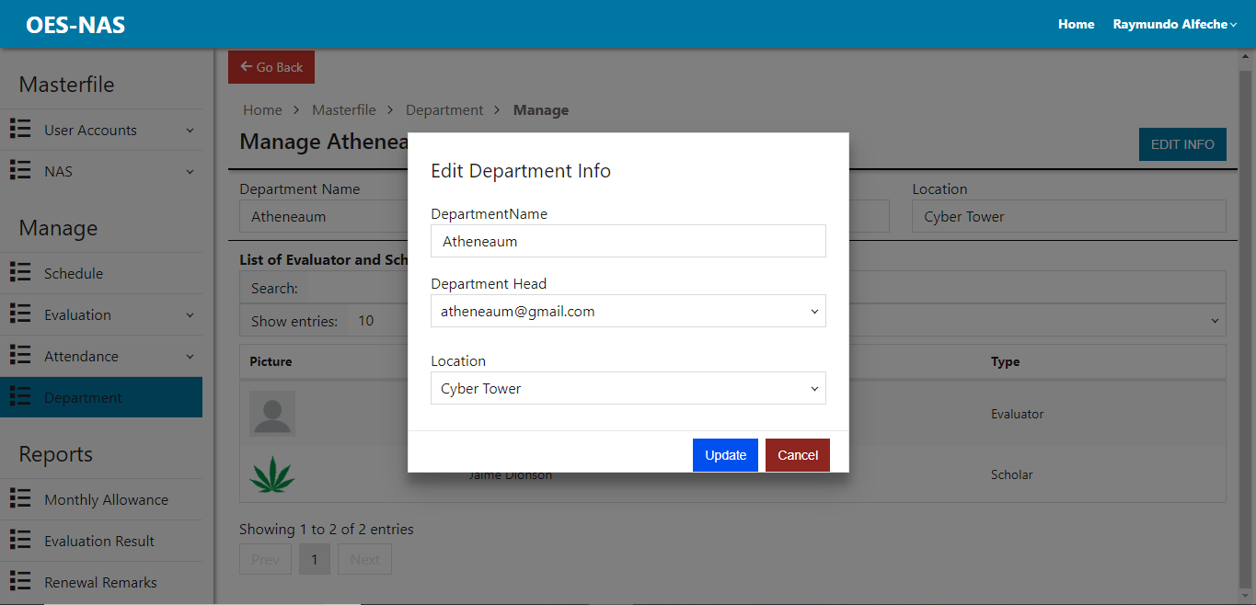

Figure 48: Edit Department Dialog

Description: This dialog is where the admin can edit department info specially choosing the head of the department.

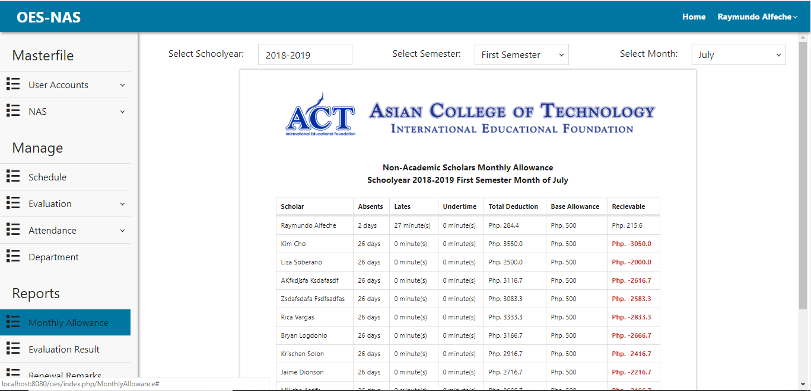

Figure 49: Monthly Allowance Report Page

Description: This page allows the admin to generate monthly allowance report based on the DTR and Working dates.

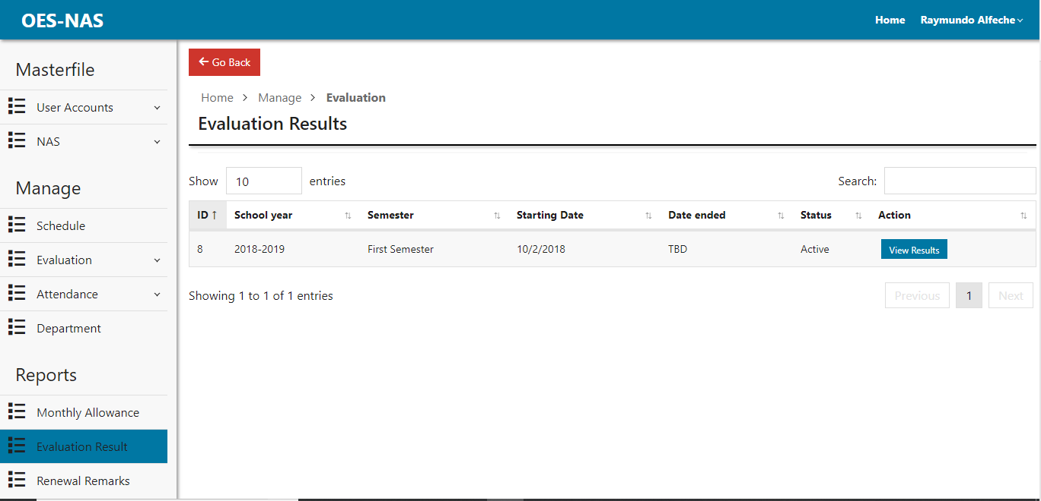

Figure 50: Choosing of Evaluation Results Page

Description: This page allows the admin to choose evaluation results.

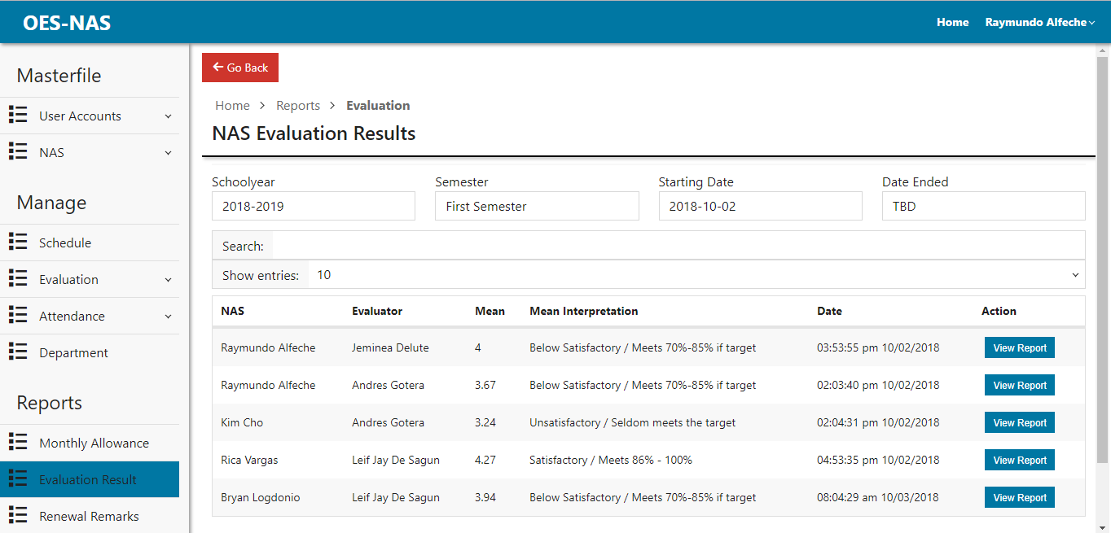

Figure 51: NAS Evaluation Results Page

Description: This page allows the admin to view NAS Evaluation results.

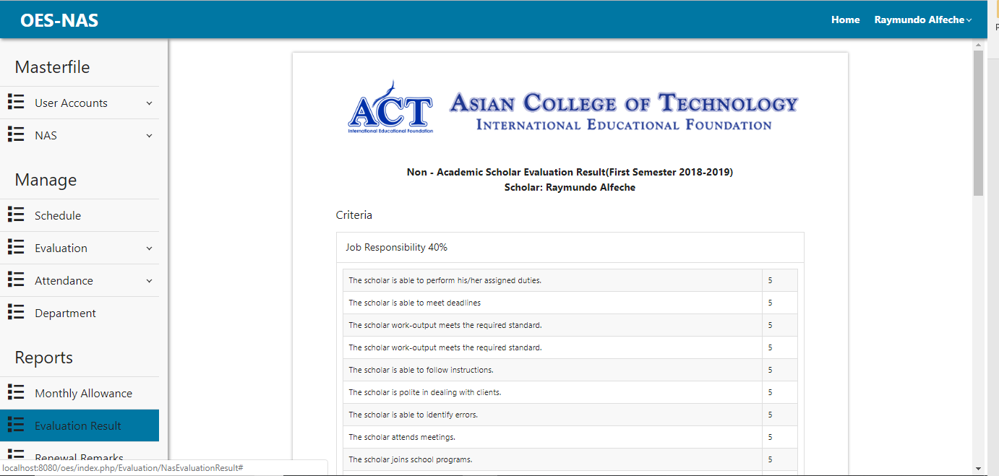

Figure 52: NAS Evaluation Report

Description: This page is a generated report of the NAS Evaluation and can be printed.

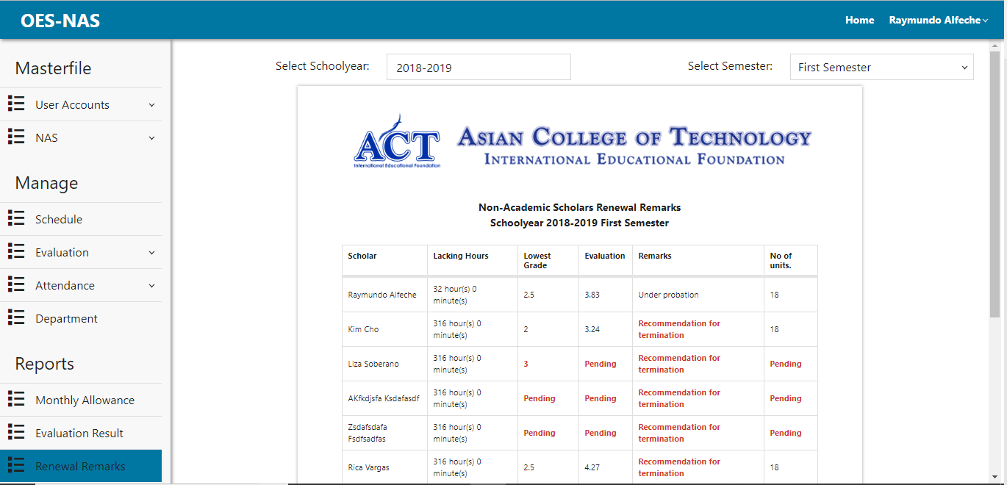

Figure 53: Renewal Remarks Report Page

Description: This page allows the admin to generate renewal report. The admin can print the report or save it as PDF.

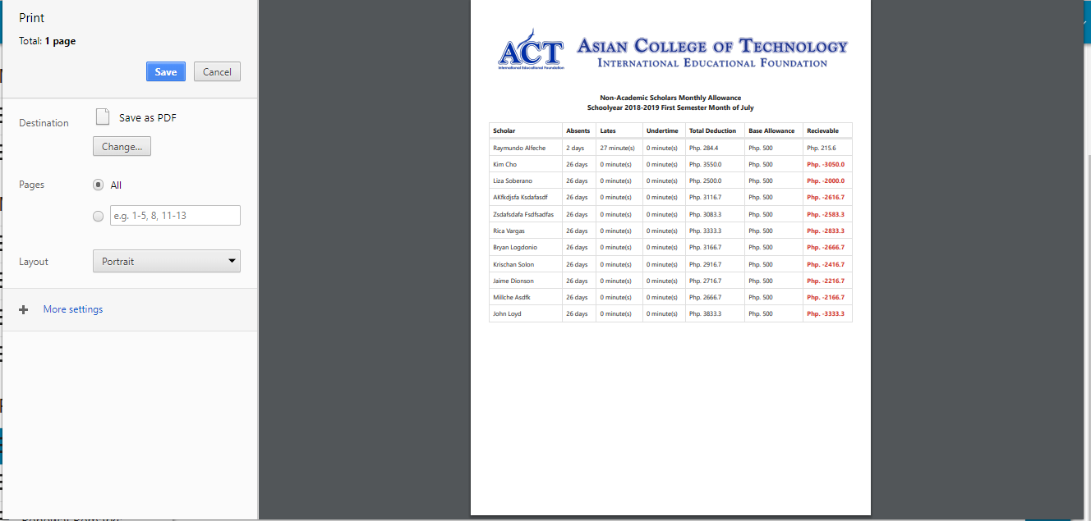

Figure 54: Monthly Allowance Report Print Dialog

Description: This dialog is the admin can Print Monthly allowance report or save it as PDF.

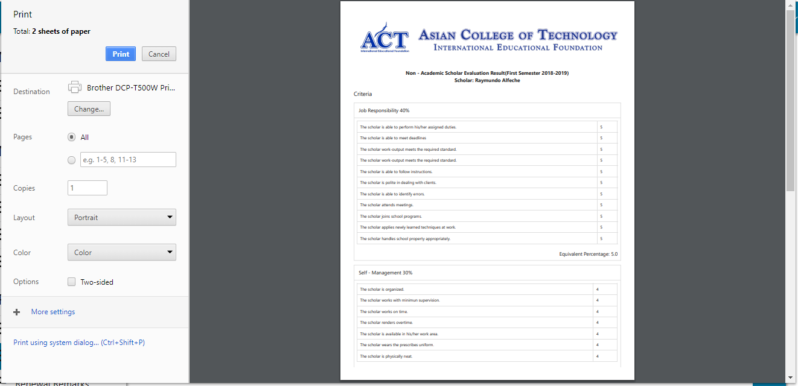

Figure 55: NAS Evaluation Results Print Dialog

Description: This dialog is where the admin can print NAS evaluation result report or save it as PDF.

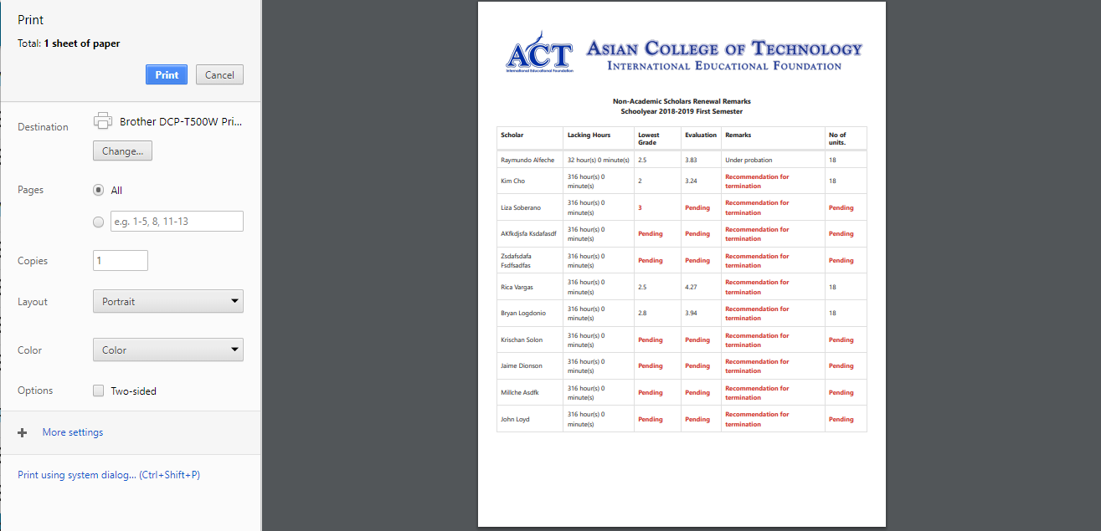

Figure 56: Renewal Remarks Report Print Dialog

Description: This dialog is where the admin can print NAS renewal remark report or save it as PDF.

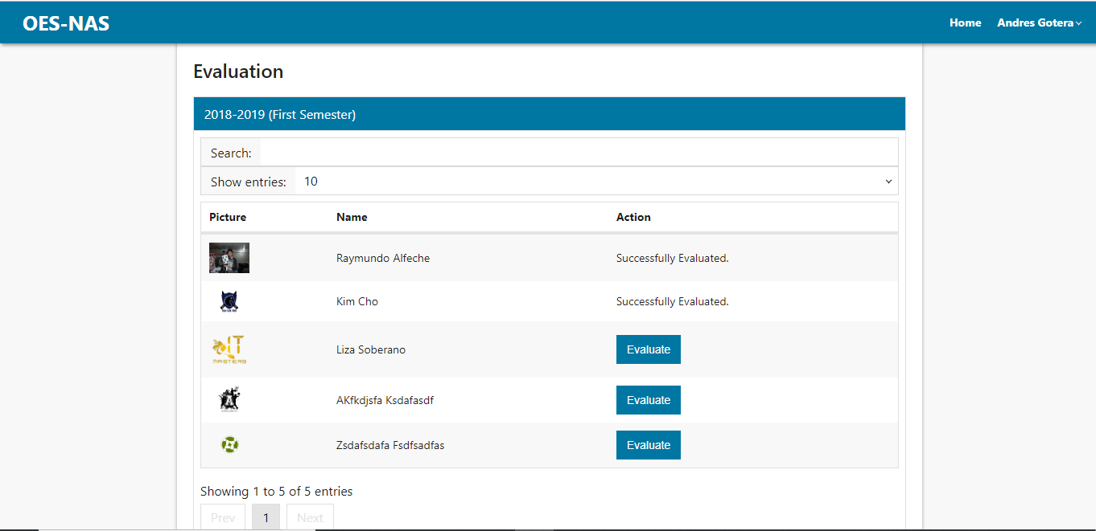

Figure 57: Evaluator Home Page

Description: This is the evaluator’s home page where they can initiate the evaluation of scholars in their department. It shows scholars they have successfully evaluated and not.

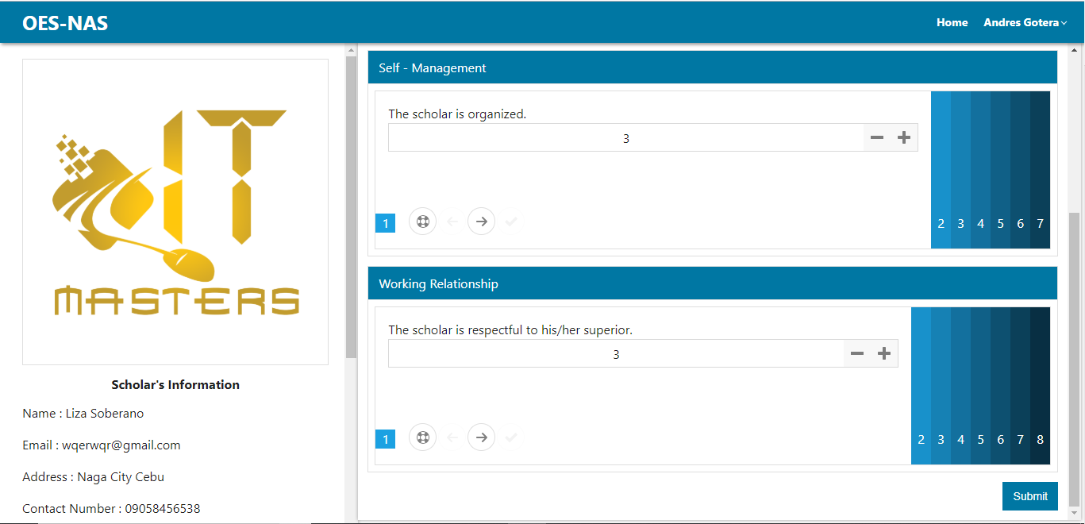

Figure 58: NAS Evaluation Page

Description: This page will be the evaluation page for NAS. In this page the evaluator can evaluate their scholar base on the questions given by the administrator. Questions are also being organized.

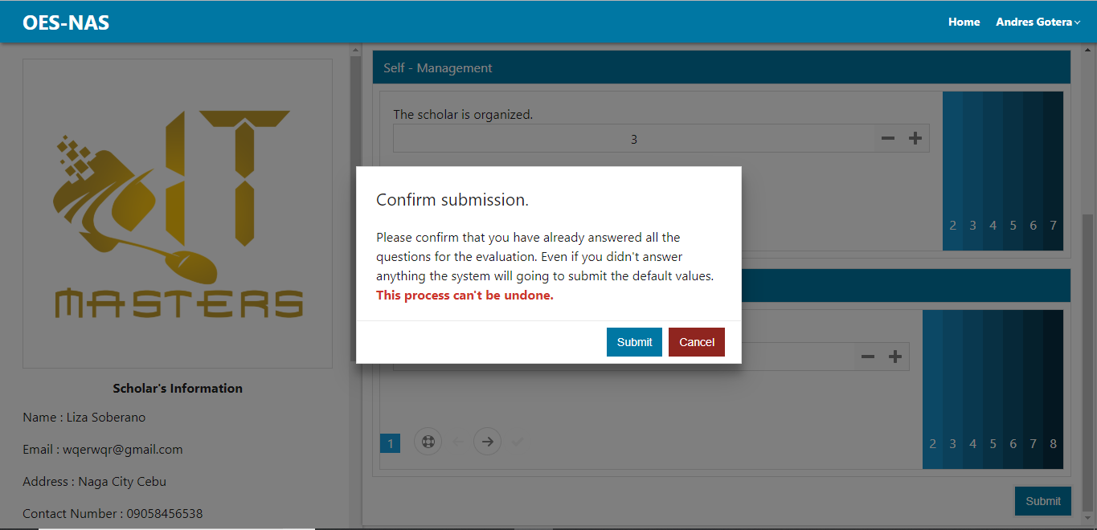

Figure 59: NAS Evaluation Submission Confirmation

Description: This dialog is a confirmation if the evaluator had answered the questions properly.

## Chapter 5

### COST AND BENEFITS ANALYSIS

The System Specification

Hardware Specification : Samsung LED

Monitor : A4Tech OPTICAL MOUSE USB

Motherboard : MS-A88FE Turbo M.2

Keyboard : A4Tech USB BLACK USB

AVR : MONSTER 500 Watts BLACK

Processor : Core i3 5005U Intel 2 GHz 3MB

Hard Drive : 500GB

RAM : 4GB DDR3

Printer : Epson L210 Series

Software Specification

Browser : Google Chrome

(Recommended)

DBMS : XAMMP

OS Platform : Windows 8.1 64 Bit

Domain and Host : zoom.ph

System Requirements Cost

Hardware Php26,499.00 Software 9,967.96

Total System Requirements Cost Php 36,466.96

Operating Cost of the System

Current Operating Cost of the System

General Supplies Php 11,856.00

Total Current Operating Cost of the System Php 11,856.00

Proposed Operating Cost of the System

General Supplies Php 8,160.00

Total Proposed Operating Cost of the System Php 8,160.00

Payback Period

Future Value (FV) = Total Operating Cost of the Proposed System – Total Current Operating Cost of the System

Current System

= P 8,160.00 – P 11,856.00

= P - 3,696.00

### Benefits

The proposed system will provide the Online Evaluation System in ACT.

The system manages or handles the results of the evaluation. The proposed system when applied will benefit the Asian College of technology in terms of the following.

* Reliability – The proposed system will be up 24/7 a day and will secure gathered data in database and creates back-up which can be retrieved if necessary.
* Convenience – the administrator can serve easily and meet the needs of their evaluator. They will find it easy to process their computations. Thus, it eliminates hassle in their part and they will be the one to input the details needed.
* Efficiency - Fast and accurate in generating the reports, gathering data and getting the results.
* Time management – The evaluation administrator can achieve a job with minimum expenditure and leisure of effort and time.
* Cost – There will be lesser supplies expense or spending in terms of buying printing and ink toners.

# Chapter 6

## CONCLUSION AND RECOMMENDATION

### Conclusion

Based on the outcome of the study, the proponents concluded that the proposed system is better to use than the current system. Through the proposed system of the proponents Online Evaluation System for NAS of ACT, the school will be able to generate the evaluation result and monthly allowance more efficiently. Therefore, the alternative has been presented to develop a system in order to lessen time and accessibility consumed by the admin of the school.

### Recommendation

The researchers highly recommended changing their manual flow of Activity Evaluation System and use the Automated Online Evaluation System for better result. This would somehow lessen the difficulties in getting the result after evaluating. It has been proposed to distinguish and answer the problems of activity evaluation with the current system of the school. It can support their evaluation process run precisely, smoothly and successfully. Finally, generating report can be easily like evaluation result with less hassle.

## REFERENCES

1. Published

Lazar, J. and J. Preece Summber 1999. “Designing and Implementing Web-Based Surveys.” Journal of Computer Information System, 39(4), pp. 63-67. Retrieved from

New Art Technologies, Inc., 514 Portside Dr., Edgewater, NJ 07020. Zeliff, N.D., 2000. “Alternative assessment.” National Business Education Yearbook 2000, pp. 91-102. Retrieved from

1. Unpublished

Cardwell, K., April 2000, “Electronic Assessment.” Learning and Leading with Technology, 27(7), pp. 22-26. Dunn, S. L., March-April 2000, “The Virtualizing of Education.” The Futurist, 34(2), pp. 34-38. Gibson, J.W., D. V. Tesone, and C.W.

Blackwell, Winter 2001. “The Journey to Cyberspace: Reflections From Three Online Business Professors.” S.A.M. Advanced Management Journal, 66(1), pp. 30-34. Landolt, S.C., July 1999. “On-line testing.” Credit Union Management, 22(7), p.66.

1. Websites

Gerald F. Braun (2000). Department of Information Systems in Xavier University. Retrieved from Mckeachie, W. and Svinicki, M. (2006), evaluations are commonly considered for summative purposes, including tenure, merit increase, retention for non-tenured faculty, promotion, and course assignment decisions.

# Appendix A

## GLOSSARY OF TERMS

Automate. Concert (a process or facility) to largely automatic operation.

Class Diagram. A type of static structure diagram that describes the structure of a system by showing the system’s classes, their attributes and the relationships between the classes.

Component Diagram. It shows the structural design which displays the connection between its software components used in the system.

Data. A collection of facts from which it is processed for raw information that is needed in the system and that conclusions may be drawn.

Evaluation. The making of a judgment about the amount, number, or value of something assessment.

Functional Requirement. It is a capability of a system to satisfy, fulfil or comply with. It is also a description of any of the functions of a software system.

Gantt Chart. A graphical representation of the tasks and resources needed to complete a job or project; may show ranges of possible start and end dates and the relationships between tasks.

Manual. A thing operated or done by hand rather than automatically or electronically, in particular

Non- Functional Requirement. A requirement of a piece of software, such as accessibility or portability that is not a specific, measurable aspect of performing a particular task.

Reports. A document containing the information and the computed data results from a specified or allocated group of data.

System. A set of principles or procedures according to which something is done, an organized scheme or method.

Use Case. A description of a potential scenario in which a system receives an external request (such as user input) and responds to it.

Web-based. Is any program that is accessed over a network connection using HTTP, rather than existing within a device’s memory

# Appendix B

## MODELLING TOOLS

The Use Case Diagram

Use Case

* is a list of actions or event steps typically defining the interactions between a role (known in the Unified Modeling Language as an actor) and a system to achieve a goal.

**USE CASE**

Actor

- Characters who play individual vital roles upon using the system. Those users can be either humans or computer systems. They must interact to get things done and must also be part of the system which will also receive reports from it.

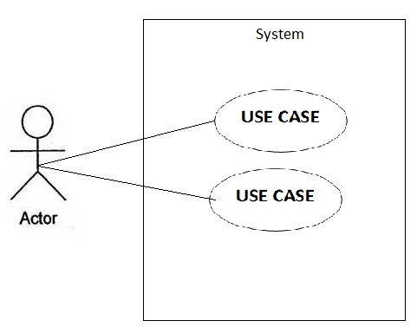

System

- It is a process which describes the indication of the entered data shows the expected output of data response. The system use case will illustrate how the actor itself and the system works together.

Extended Use Case

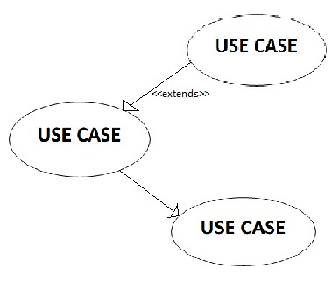

- Extended use case is independent and can be extended from itself. It has a different relationship on its own and typically describes an optional behavior to use cases being extended.

Included Use Case

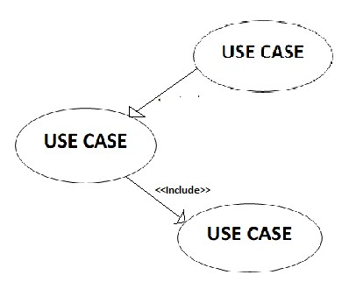

- Included use case is a required direct relationship between two use cases which is made depending upon the addition of the use case together with its behavior.

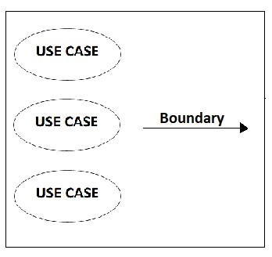System Boundary

- It is used in a use case diagram to show and define the limitations pertaining the functionalities of the system. The system boundary is illustrated as a rectangle.

Component Diagram

- A component diagram is one of the individual parts of which a composite and logical entity is made up especially that can be separated from or attached to a system which represents things such as manufacturing components, deployment

**Component**

Components or implementation components that is needed to complete a system.

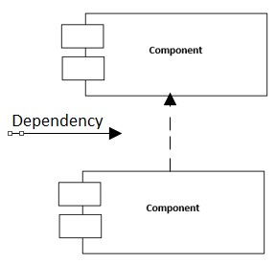Dependency

- It is a relationship which represents one model showing a reliance and precedence to the other model. Dependency relationships is denoted with a dashed arrow and does not have names on it.

Associate Line

- It shows new instances of entities or classes between the usages of the user towards the capability of what the system can do.

Generalization Line

- It shows the “is a” relationships between classes and its inheritance of one another.

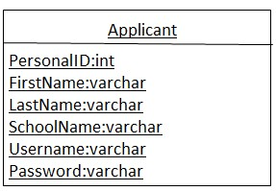Class Diagram

- A type of static structure diagram that defines the structure of a system by presenting the system’s classes, their attributes, and the associations between the classes

# Appendix C

FORMS AND EXHIBITS

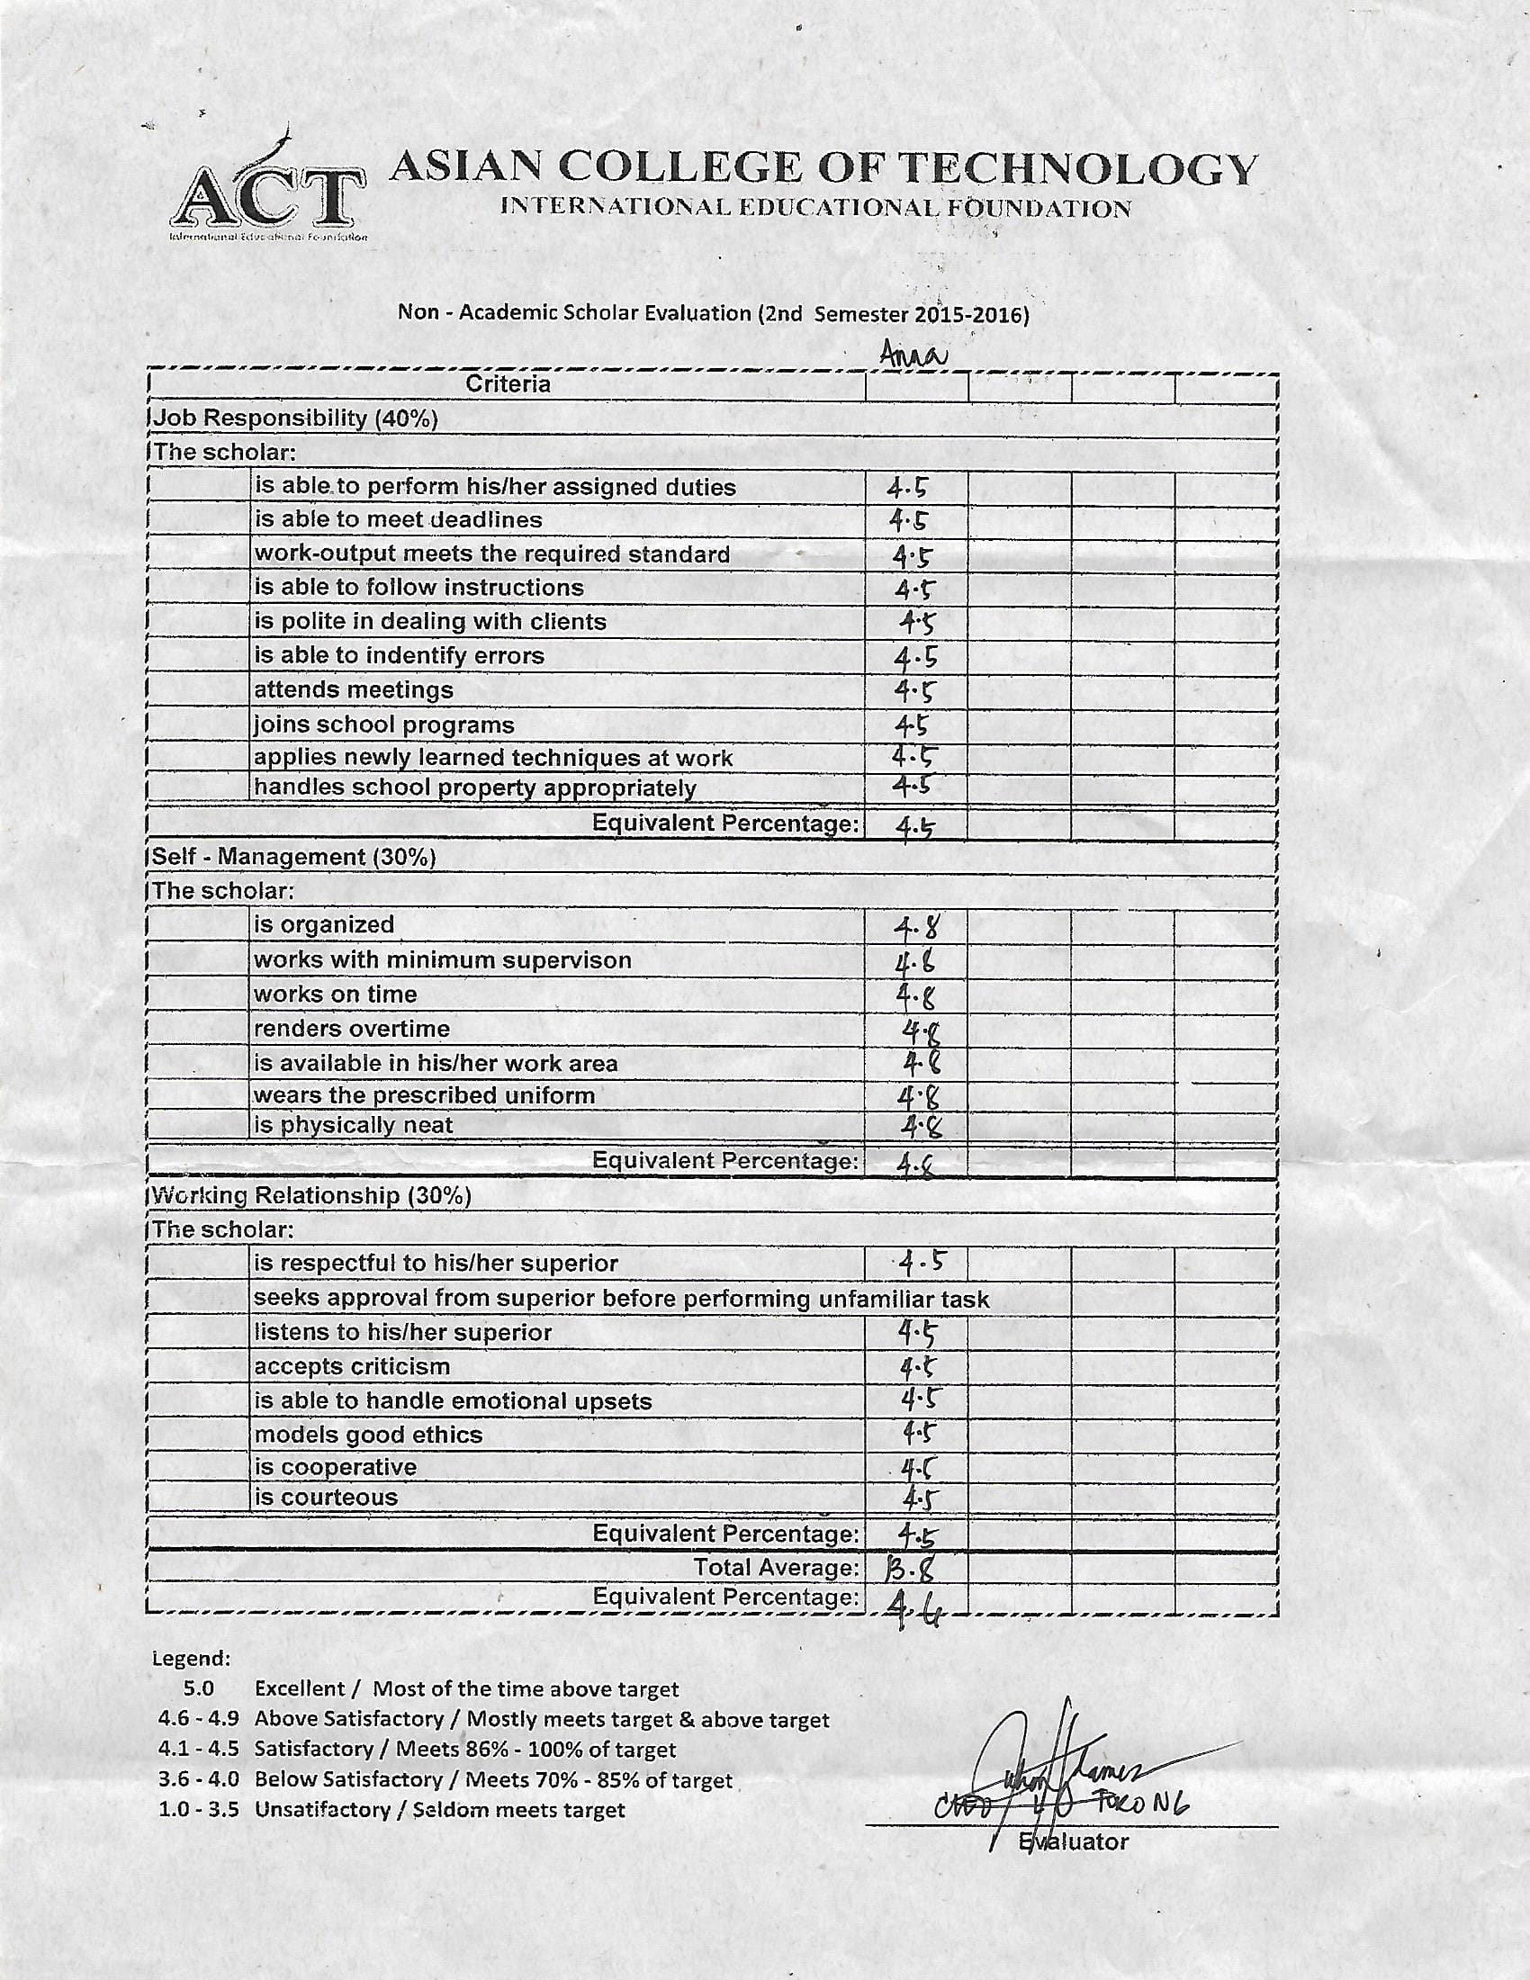

Figure 60: Evaluation Form Sample

Name: NAS Evaluation form

Purpose: This is the form for the evaluation of Non Academic Scholars.

# Appendix D

## TRANSMITTAL LETTER



Figure 61: Transmittal Letter

## Appendix E

## FLOW OF THE SYSTEM

### Flow of the System

The current process of evaluating NAS and calculation of monthly allowance involves insufficient records, skill, knowledge and time-consuming to the Administrator of Non-Academic Scholars in Asian College of Technology.

Current System Flow

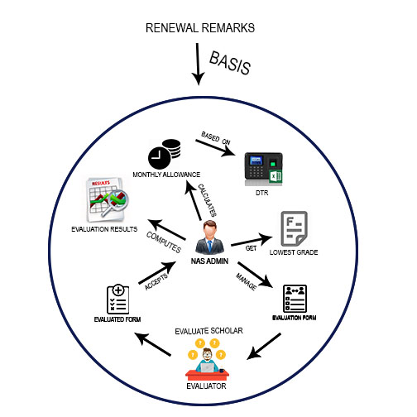

Figure 62: Current system flow on Evaluation of NAS in ACT

Description: The current system flow on Evaluation of NAS in ACT, the NAS Admin will manage and prepare for the evaluation form and distribute it to the evaluator of every department. Then the evaluator will evaluate the form and send it back to the Admin. The Admin will compute evaluation results needed for the renewal remark. Attendance is part of the criteria of renewal remark so the admin will calculate attendance along with the monthly allowance based on DTR from the biometric machine. Grade is also part of renewal remark so the admin will going to get the lowest grade and calculate its average. After getting the results needed for renewal remark the admin will going to make a report for the renewal remark.

### Proposed System Flow

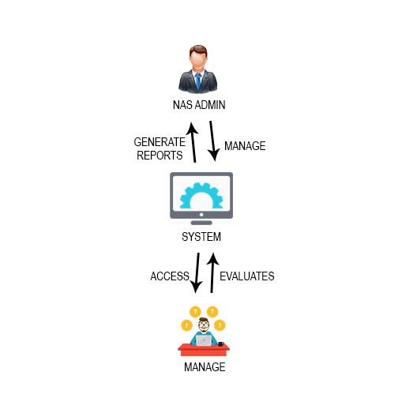

Figure 63: Proposed system flow on evaluation of NAS in ACT

Description: The proposed flow, the admin will going to manage the system and the evaluator will going access and evaluate the system on-line. The system will going generate reports needed for the evaluation.

## Appendix F

INTERVIEW QUESTIONS

1. What is the importance of having evaluation for the Non-Academic Scholars?
2. Who are the evaluator’s for the evaluation?
3. What are the problems or issues in the current process?
4. How do you solve these problems/issues?
5. How are the evaluation form being distributed to the evaluator?
6. What are the ways of getting the statistics of the evaluation?

Dr. Andres S. Gotera

Director of Student Welfare and Services

## Appendix G

## PARTICULARS OF THE OPERATING COST OF THE SYSTEM

Operating Cost of the System

Current Operating Cost of the System

Supplies

|  |  |  |  |
| --- | --- | --- | --- |
| Short Bond Paper (Php 300\*12) | |  | Php 3,600.00 |
| Long Bond Paper (Php 380\*12) | |  | 4,560.00 |
| Ballpen (Php 25\*5\*12) | |  | 1,500.00 |
| Long Brown Envelope (Php 7\*10\*12) | |  | 840.00 |
| Long Folder (Php 6\*3\*12) |  |  | 216.00 |
| Short Folder (Php 5\*3\*12) |  |  | 180.00 |
| Fastener (Php 45\*12) |  |  | 540.00 |
| Paper clips (Php 35\*12) |  |  | 420.00 |

Total Operating Cost of the Current System Php 11,856.00

Proposed Operating Cost of the System

Supplies

|  |  |  |
| --- | --- | --- |
| Short Bond Paper (Php 300\*12) |  | Php 3,600.00 |
| Long Bond Paper (Php 380\*12) |  | 4,560.00 |
| Total Operating Cost of the Proposed System |  | Php 8,160.00 |

## Appendix H DATA MODEL OF THE SYSTEM

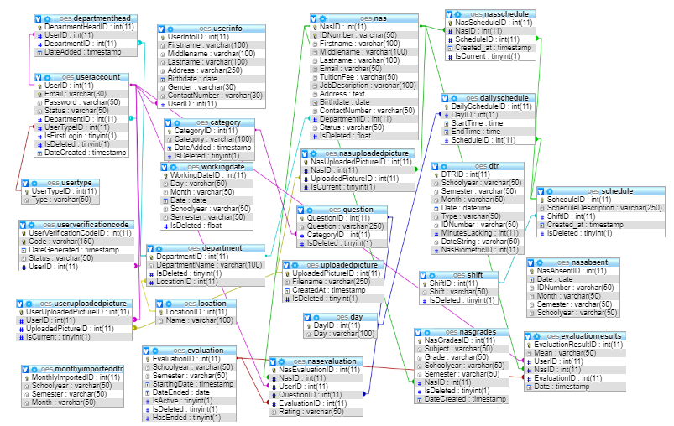

Figure 64: Data Model of Online Evaluation System for Non-Academic Scholars of Asian College of Technology

# Appendix I

## SAMPLE PROGRAM CODE

**CONTROLLER Evaluation.php**

<?php

/\*\*

\*

\*/

class Evaluation extends CI\_Controller

{

function \_\_construct()

{

parent::\_\_construct();

$this->load->model('EvaluationModel');

$this->load->model('CategoryModel');

$this->load->model('QuestionModel');

$this->load->model('SchoolyearModel');

$this->load->model('NasModel');

$this->load->model('UserInfoModel');

$this->load->model('EvaluationResultsModel');

}

public function Question()

{

if(isset($\_SESSION['Email'])){

if($\_SESSION['Status']=="Verified"){

if($\_SESSION['IsFirstLogin']=="1"){

header('location:'.base\_url('index.php/Login'));

}else{

if($\_SESSION['UserTypeID']==1){

$data['Title']="OES-Evaluation Question";

$data['useraccounts']="";

$data['nas']="";

$data['eval']="";

$data['scheduler']="";

$data['department']="";

$data['evaluation']="active";

$data['category']=$this->CategoryModel->getCategory();

$this->load->view('layout/header',$data);

$this->load->view('admin/eval\_question\_page');

}else{

header('location:'.base\_url('index.php/Evaluator'));

}

}

}else{

header('location:'.base\_url('index.php/Login'));

}

}else{

header('location:'.base\_url('index.php/Login'));

}

}

public function QuestionCategory()

{

if(isset($\_SESSION['Email'])){

if($\_SESSION['Status']=="Verified"){

if($\_SESSION['IsFirstLogin']=="1"){

header('location:'.base\_url('index.php/Login'));

}else{

if($\_SESSION['UserTypeID']==1){

$data['Title']="OES-Question Category";

$data['useraccounts']="";

$data['nas']="";

$data['eval']="";

$data['scheduler']="";

$data['department']="";

$data['evaluation']="active";

$this->load->view('layout/header',$data);

$this->load->view('admin/question\_category\_page');

}else{

header('location:'.base\_url('index.php/Evaluator'));

}

}

}else{

header('location:'.base\_url('index.php/Login'));

}

}else{

header('location:'.base\_url('index.php/Login'));

}

}

public function ImportQuestion()

{

if(isset($\_SESSION['Email'])){

if($\_SESSION['Status']=="Verified"){

if($\_SESSION['IsFirstLogin']=="1"){

header('location:'.base\_url('index.php/Login'));

}else{

if($\_SESSION['UserTypeID']==1){

$data['Title']="OES-Import Category";

$data['useraccounts']="";

$data['nas']="";

$data['eval']="";

$data['scheduler']="";

$data['department']="";

$data['evaluation']="active";

$data['category']=$this->CategoryModel->getCategory();

$this->load->view('layout/header',$data);

$this->load->view('admin/import\_evaluation\_question\_page');

}else{

header('location:'.base\_url('index.php/Evaluator'));

}

}

}else{

header('location:'.base\_url('index.php/Login'));

}

}else{

header('location:'.base\_url('index.php/Login'));

}

}

public function Manage()

{

if(isset($\_SESSION['Email'])){

if($\_SESSION['Status']=="Verified"){

if($\_SESSION['IsFirstLogin']=="1"){

header('location:'.base\_url('index.php/Login'));

}else{

if($\_SESSION['UserTypeID']==1){

$data['Title']="OES-Manage Evaluation";

$data['useraccounts']="";

$data['nas']="";

$data['eval']="";

$data['scheduler']="";

$data['department']="";

$data['evaluation']="active";

$this->load->view('layout/header',$data);

$this->load->view('admin/manage\_evaluation\_page');

}else{

header('location:'.base\_url('index.php/Evaluator'));

}

}

}else{

header('location:'.base\_url('index.php/Login'));

}

}else{

header('location:'.base\_url('index.php/Login'));

}

}

public function Monitor($id)

{

if(isset($\_SESSION['Email'])){

if($\_SESSION['Status']=="Verified"){

if($\_SESSION['IsFirstLogin']=="1"){

header('location:'.base\_url('index.php/Login'));

}else{

if($\_SESSION['UserTypeID']==1){

$data['Title']="OES-Manage Evaluation";

$data['useraccounts']="";

$data['nas']="";

$data['eval']="";

$data['scheduler']="";

$data['department']="";

$data['evaluation']="active";

$data['eval']=$this->EvaluationModel->getEvaluationByID($id);

$data['evalres']=$this->EvaluationResultsModel->getEvaluationLogs($id);

$this->load->view('layout/header',$data);

$this->load->view('admin/monitor\_evaluation\_page');

}else{

header('location:'.base\_url('index.php/Evaluator'));

}

}

}else{

header('location:'.base\_url('index.php/Login'));

}

}else{

header('location:'.base\_url('index.php/Login'));

}

}

public function Results()

{

if(isset($\_SESSION['Email'])){

if($\_SESSION['Status']=="Verified"){

if($\_SESSION['IsFirstLogin']=="1"){

header('location:'.base\_url('index.php/Login'));

}else{

if($\_SESSION['UserTypeID']==1){

$data['Title']="OES-Evaluation Results";

$data['useraccounts']="";

$data['nas']="";

$data['eval']="";

$data['scheduler']="";

$data['department']="";

$data['evaluation']="";

$data['evaluationresultsnav']="active";

$this->load->view('layout/header',$data);

$this->load->view('admin/evaluation\_results\_page');

}else{

header('location:'.base\_url('index.php/Evaluator'));

}

}

}else{

header('location:'.base\_url('index.php/Login'));

}

}else{

header('location:'.base\_url('index.php/Login'));

}

}

public function NasEvaluationResult()

{

if(isset($\_SESSION['Email'])){

if($\_SESSION['Status']=="Verified"){

if($\_SESSION['IsFirstLogin']=="1"){

header('location:'.base\_url('index.php/Login'));

}else{

if($\_SESSION['UserTypeID']==1){

$data['Title']="OES-Evaluation Results";

$data['useraccounts']="";

$data['nas']="";

$data['eval']="";

$data['scheduler']="";

$data['department']="";

$data['evaluation']="";

$data['evaluationresultsnav']="active";

$data['nasprofile']=$this->NasModel->getNasProfile($\_SESSION['resultNasID']);

$data['userprofile']=$this->UserInfoModel->getUserAccountInfo($\_SESSION['resultUserID']);

$data['evaldata']=$this->EvaluationModel->getEvaluationByID($\_SESSION['resultEvalID']);

$this->load->view('layout/header',$data);

$this->load->view('admin/nas\_evaluation\_report');

}else{

header('location:'.base\_url('index.php/Evaluator'));

}

}

}else{

header('location:'.base\_url('index.php/Login'));

}

}else{

header('location:'.base\_url('index.php/Login'));

}

}

public function ViewResults($id)

{

if(isset($\_SESSION['Email'])){

if($\_SESSION['Status']=="Verified"){

if($\_SESSION['IsFirstLogin']=="1"){

header('location:'.base\_url('index.php/Login'));

}else{

if($\_SESSION['UserTypeID']==1){

$data['Title']="OES-Evaluation Results";

$data['useraccounts']="";

$data['nas']="";

$data['eval']="";

$data['scheduler']="";

$data['department']="";

$data['evaluation']="";

$data['evaluationresultsnav']="active";

$data['eval']=$this->EvaluationModel->getEvaluationByID($id);

$data['evalres']=$this->EvaluationResultsModel->getEvaluationLogs($id);

$this->load->view('layout/header',$data);

$this->load->view('admin/view\_result\_page');

}else{

header('location:'.base\_url('index.php/Evaluator'));

}

}

}else{

header('location:'.base\_url('index.php/Login'));

}

}else{

header('location:'.base\_url('index.php/Login'));

}

}

public function getEvaluation()

{

$data['eval']=$this->EvaluationModel->Get();

$data['success']=false;

if($data){

$data['success']=true;

}

echo json\_encode($data);

}

public function setResultsSession()

{

$\_SESSION['resultNasID']=$this->input->post('NasID');

$\_SESSION['resultUserID']=$this->input->post('UserID');

$\_SESSION['resultEvalID']=$this->input->post('EvalID');

}

public function getNasEvaluationCategoryResult()

{

$data['nasevalcat']=$this->EvaluationResultsModel->getNasEvaluationCategoryResult($\_SESSION['resultNasID'],$\_SESSION['resultUserID'],$\_SESSION['resultEvalID']);

$data['success']=false;

if($data){

$data['success']=true;

}

echo json\_encode($data);

}

public function getNasEvaluationQuestionResultByCategory()

{

$data['nasevalquestion']=$this->EvaluationResultsModel->getNasEvaluationQuestionResultByCategory($\_SESSION['resultNasID'],$\_SESSION['resultUserID'],$\_SESSION['resultEvalID'],$this->input->post('ID'));

$data['success']=false;

if($data){

$data['success']=true;

}

echo json\_encode($data);

}

public function endEvaluation()

{

$where = array('EvaluationID' => $this->input->post('ID') );

$query=$this->EvaluationModel->endEvaluation($where);

$data['success']=false;

if($query){

$data['success']=true;

}

echo json\_encode($data);

}

public function addEvaluation()

{

if($this->EvaluationModel->checkUndoneEvaluation()){

$data['hasundone']=true;

$data['success']=false;

}else{

$fields = array('Schoolyear' => $this->input->post('dtpAddEvalYear1')."-".$this->input->post('txtAddEvalYear'),'Semester'=>$this->input->post('cmbAddEvalSemester'),'StartingDate'=>$this->input->post('dtpStartingDate') );

$query=$this->EvaluationModel->Add($fields);

$data['success']=false;

if($query){

$data['success']=true;

}

}

echo json\_encode($data);

}

public function changeStatus()

{

$where = array('EvaluationID' => $this->input->post('ID'));

if($this->input->post('Status')=='Deactivated'){

$fields = array('IsActive' => 1 );

$query=$this->EvaluationModel->changeStatus($where,$fields);

$data['success']=false;

if($query){

$data['success']=true;

}

echo json\_encode($data);

}else{

$fields = array('IsActive' => 0 );

$query=$this->EvaluationModel->changeStatus($where,$fields);

$data['success']=false;

if($query){

$data['success']=true;

}

echo json\_encode($data);

}

}

public function deleteEvaluation()

{

$where = array('EvaluationID' =>$this->input->post('ID') );

$query=$this->EvaluationModel->Delete($where);

$data['success']=false;

if($query){

$data['success']=true;

}

echo json\_encode($data);

}

public function getQuestion()

{

$data['question']=$this->QuestionModel->getQuestion($this->input->post('ID'));

$data['success']=false;

if($data){

$data['success']=true;

}

echo json\_encode($data);

}

public function addSchoolyear()

{

$date = DateTime::createFromFormat("Y-m-d", $this->input->post('dtpYear'));

$year=$date->format("Y");

$newyear=(int)$year+1;

$field = array('Year' => ($year."-".$newyear));

$query=$this->SchoolyearModel->addSchoolyear($field);

$data['success']=false;

if($query){

$data['success']=true;

}

echo json\_encode($data);

}

public function getSchoolyear()

{

$data['sy']=$this->SchoolyearModel->getSchoolyear();

$data['success']=false;

if($data){

$data['success']=true;

}

echo json\_encode($data);

}

public function deleteSchoolyear()

{

$where = array('SchoolyearID' => $this->input->post('ID') );

$query=$this->SchoolyearModel->deleteSchoolyear($where);

$data['success']=false;

if($query){

$data['success']=true;

}

echo json\_encode($data);

}

public function uploadTempExcel()

{

$config['upload\_path']='./assets/temp\_files';

$config['allowed\_types']='xlsx|xlsm|xltx|xltm';

$config['file\_name'] = $this->input->post("Filename");

$this->load->library('upload',$config);

$data['success']=false;

if($this->upload->do\_upload('txtFile')){

$upload=$this->upload->data();

$data['success']=true;

$data['filename']=$upload['file\_name'];

}

echo json\_encode($data);

}

public function uploadExcel()

{

$config['upload\_path']='./assets/uploads/Excel';

$config['allowed\_types']='xlsx|xlsm|xltx|xltm';

$config['file\_name'] = $this->input->post("Filename");

$this->load->library('upload',$config);

$data['success']=false;

if($this->upload->do\_upload('txtFile')){

$upload=$this->upload->data();

$data['success']=true;

$data['filename']=$upload['file\_name'];

}

echo json\_encode($data);

}

public function importQuestions()

{

$fields = array('Question' =>$this->input->post('Question'),'CategoryID'=>$this->input->post('CategoryID') );

$query=$this->QuestionModel->Add($fields);

$data['success']=false;

if($query){

$data['success']=true;

}

echo json\_encode($data);

}

public function deleteQuestion()

{

$where = array('QuestionID' => $this->input->post('ID'));

$query=$this->QuestionModel->Delete($where);

$data['success']=false;

if($query){

$data['success']=true;

}

echo json\_encode($data);

}

public function updateQuestion()

{

$where = array('QuestionID' => $this->input->post('txtEditQuestionID') );

$fields = array('Question' => $this->input->post('txtEditQuestion'),'CategoryID'=>$this->input->post('cmbEditQuestionCategory') );

$query=$this->QuestionModel->Update($where,$fields);

$data['success']=false;

if($query){

$data['success']=true;

}

echo json\_encode($data);

}

public function addQuestion()

{

$fields = array('Question' => $this->input->post('txtAddQuestion'),'CategoryID' => $this->input->post('cmbAddCategory') );

$query=$this->QuestionModel->Add($fields);

$data['success']=false;

if($query){

$data['success']=true;

}

echo json\_encode($data);

}

public function getCategory()

{

$data['success']=false;

$data['category']=$this->CategoryModel->getCategory();

if($data){

$data['success']=true;

}

echo json\_encode($data);

}

public function updateCategory()

{

$where = array('CategoryID' => $this->input->post('txtEditCatID') );

$fields = array('Category' => $this->input->post('txtEditCat') );

$data['success']=false;

$query=$this->CategoryModel->Update($where,$fields);

if($query){

$data['success']=true;

}

echo json\_encode($data);

}

public function addCategory()

{

$fields = array('Category' => $this->input->post('txtAddCategory'));

$query=$this->CategoryModel->Add($fields);

$data['success']=false;

if($query){

$data['success']=true;

}

echo json\_encode($data);

}

public function deleteCategory()

{

$where = array('CategoryID' => $this->input->post('ID') );

$query=$this->CategoryModel->Delete($where);

$data['success']=false;

if($query){

$data['success']=true;

}

echo json\_encode($data);

}

}

?>

# D:\REFORMAT BACKUP\PICTURES\DSC_0918.JPGCURRICULUM VITAE

PERSONAL DATA:

Name : Raymundo R. Alfeche Jr.

Address : Inoburan Naga City

Date of Birth : April 11, 1999

Age : 19

Civil Status : Single

Father’s Name : Raymundo R. Alfeche Jr.

Mother’s Name : Fedila R. Alfeche

Contact No. : 09752186818

EDUCATIONAL ATTAINMENT:

Elementary Level

Name of School : Liburon Elementary School

Address : Liburon San Fernando Cebu

Year Graduated : 2011

Secondary Level

Name of School : Sangat National High School

Address : Sangat San Fernando Cebu

Year Graduated : 2014

Tertiary Level

Name of School : Asian College of Technology

Address : Corner Leon Kilat & P. del Rosario St., Cebu, City

Course : Bachelor of Science in Information Technology